


Clean and maintain industrial work area and equipment
D1.HHK.CL3.07
Trainee Manual




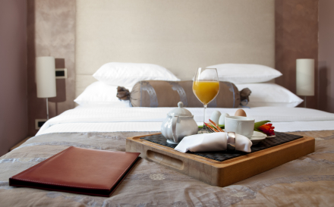

Clean and maintain industrial work area and equipment

D1.HHK.CL3.07

Trainee Manual





Project Base
William Angliss Institute of TAFE
555 La Trobe Street
Melbourne 3000 Victoria
Telephone: | (03) 9606 2111
Facsimile: | (03) 9670 1330
Acknowledgements
Project Director: | Wayne Crosbie
Chief Writer: | Alan Hickman
Subject Writer: | Barbara Sargeant
Project Manager/Editor: | Alan Maguire
DTP/Production | Daniel Chee, Mai Vu, Jirayu Thangcharoensamut, Kaly Quach

The Association of Southeast Asian Nations (ASEAN) was established on 8 August 1967. The Member States of the Association are Brunei Darussalam, Cambodia, Indonesia, Lao PDR, Malaysia, Myanmar, Philippines, Singapore, Thailand and Viet Nam.
The ASEAN Secretariat is based in Jakarta, Indonesia.
General Information on ASEAN appears online at the ASEAN Website: www.asean.org.
All text is produced by William Angliss Institute of TAFE for the ASEAN Project on “Toolbox Development for Priority Tourism Labour Division”.
This publication is supported by the Australian Government’s aid program through the ASEAN-Australia Development Cooperation Program Phase II (AADCP II).
Copyright: Association of Southeast Asian Nations (ASEAN) 2012.
All rights reserved.
Disclaimer
Every effort has been made to ensure that this publication is free from errors or omissions. However, you should conduct your own enquiries and seek professional advice before relying on any fact, statement or matter contained in this book. The ASEAN Secretariat and William Angliss Institute of TAFE are not responsible for any injury, loss or damage as a result of material included or omitted from this course. Information in this module is current at the time of publication. Time of publication is indicated in the date stamp at the bottom of each page.
Some images appearing in this resource have been purchased from stock photography suppliers Shutterstock and iStockphoto and other third party copyright owners and as such are non-transferable and non-exclusive. Clip arts, font images and illustrations used are from the Microsoft Office Clip Art and Media Library. Some images have been provided by and are the property of William Angliss Institute.
Additional images have been sourced from Flickr and SXC and are used under Creative Commons licence: http://creativecommons.org/licenses/by/2.0/deed.en

File name: TM_Clean_&_maintain_ind_work_area_&_Equip_refined





Table of Contents
Introduction to trainee manual 1
Unit descriptor 3
Assessment matrix 5
Glossary 7
Element 1: Identify cleaning and maintenance requirements 9
Element 2: Clean industrial work areas 25
Element 3: Clean industrial work equipment 57
Element 4: Maintain industrial work areas and equipment 77
Presentation of written work 97
Recommended reading 99
Trainee evaluation sheet 101
Trainee self-assessment checklist 103

Introduction to trainee manual

To the Trainee
Congratulations on joining this course. This Trainee Manual is one part of a ‘toolbox’ which is a resource provided to trainees, trainers and assessors to help you become competent in various areas of your work.
The ‘toolbox’ consists of three elements:
- A Trainee Manual for you to read and study at home or in class
- A Trainer Guide with Power Point slides to help your Trainer explain the content of the training material and provide class activities to help with practice
- An Assessment Manual which provides your Assessor with oral and written questions and other assessment tasks to establish whether or not you have achieved competency.
The first thing you may notice is that this training program and the information you find in the Trainee Manual seems different to the textbooks you have used previously. This is because the method of instruction and examination is different. The method used is called Competency based training (CBT) and Competency based assessment (CBA). CBT and CBA is the training and assessment system chosen by ASEAN (Association of South-East Asian Nations) to train people to work in the tourism and hospitality industry throughout all the ASEAN member states.
What is the CBT and CBA system and why has it been adopted by ASEAN?
CBT is a way of training that concentrates on what a worker can do or is required to do at work. The aim is of the training is to enable trainees to perform tasks and duties at a standard expected by employers. CBT seeks to develop the skills, knowledge and attitudes (or recognise the ones the trainee already possesses) to achieve the required competency standard. ASEAN has adopted the CBT/CBA training system as it is able to produce the type of worker that industry is looking for and this therefore increases trainees chances of obtaining employment.
CBA involves collecting evidence and making a judgement of the extent to which a worker can perform his/her duties at the required competency standard. Where a trainee can already demonstrate a degree of competency, either due to prior training or work experience, a process of ‘Recognition of Prior Learning’ (RPL) is available to trainees to recognise this. Please speak to your trainer about RPL if you think this applies to you.
What is a competency standard?
Competency standards are descriptions of the skills and knowledge required to perform a task or activity at the level of a required standard.
242 competency standards for the tourism and hospitality industries throughout the ASEAN region have been developed to cover all the knowledge, skills and attitudes required to work in the following occupational areas:
- Housekeeping
- Food Production
- Food and Beverage Service
- Front Office
- Travel Agencies
- Tour Operations.
All of these competency standards are available for you to look at. In fact you will find a summary of each one at the beginning of each Trainee Manual under the heading ‘Unit Descriptor’. The unit descriptor describes the content of the unit you will be studying in the Trainee Manual and provides a table of contents which are divided up into ‘Elements’ and ‘Performance Criteria”. An element is a description of one aspect of what has to be achieved in the workplace. The ‘Performance Criteria’ below each element details the level of performance that needs to be demonstrated to be declared competent.
There are other components of the competency standard:
- Unit Title: statement about what is to be done in the workplace
- Unit Number: unique number identifying the particular competency
- Nominal hours: number of classroom or practical hours usually needed to complete the competency. We call them ‘nominal’ hours because they can vary e.g. sometimes it will take an individual less time to complete a unit of competency because he/she has prior knowledge or work experience in that area.
The final heading you will see before you start reading the Trainee Manual is the ‘Assessment Matrix’. Competency based assessment requires trainees to be assessed in at least 2 – 3 different ways, one of which must be practical. This section outlines three ways assessment can be carried out and includes work projects, written questions and oral questions. The matrix is designed to show you which performance criteria will be assessed and how they will be assessed. Your trainer and/or assessor may also use other assessment methods including ‘Observation Checklist’ and ‘Third Party Statement’. An observation checklist is a way of recording how you perform at work and a third party statement is a statement by a supervisor or employer about the degree of competence they believe you have achieved. This can be based on observing your workplace performance, inspecting your work or gaining feedback from fellow workers.
Your trainer and/or assessor may use other methods to assess you such as:
- Journals
- Oral presentations
- Role plays
- Log books
- Group projects
- Practical demonstrations.
Remember your trainer is there to help you succeed and become competent. Please feel free to ask him or her for more explanation of what you have just read and of what is expected from you and best wishes for your future studies and future career in tourism and hospitality.

Unit descriptor
Clean and maintain industrial work area and equipment
This unit deals with the skills and knowledge required to Clean and maintain industrial work area and equipment in a range of settings within the hotel and travel industries workplace context.
Unit Code:
D1.HHK.CL3.07
Nominal Hours:
40 hours

Element 1: Identify cleaning and maintenance requirements
Performance Criteria
1.1 Identify work areas to be cleaned and maintained
1.2 Identify work equipment to be cleaned and maintained
1.3 Identify and locate instructions in relation to cleaning and maintenance

Element 2: Clean industrial work areas
Performance Criteria
2.1 Assess area to be cleaned
2.2 Select appropriate cleaning equipment and chemicals
2.3 Select the protective clothing and equipment to be used
2.4 Prepare the area
2.5 Undertake the selected cleaning process
2.6 Dispose of waste
2.7 Return area to operational condition
2.8 Clean, check and store cleaning equipment and chemicals

Element 3: Clean industrial work equipment
Performance Criteria
3.1 Assess suitability of equipment for cleaning
3.2 Select appropriate cleaning equipment and chemicals
3.3 Select the protective clothing and equipment to be used
3.4 Prepare equipment for cleaning
3.5 Clean equipment as identified
3.6 Tidy work site
3.7 Dispose of waste
3.8 Clean, check and store cleaning equipment and chemicals

Element 4: Maintain industrial work areas and equipment
Performance Criteria
4.1 Identify maintenance tasks to be undertaken
4.2 Perform maintenance tasks, as required
4.3 Report problems and faults that require additional attention
4.4 Store maintenance items and equipment
4.5 Perform required administrative tasks
4.6 Assist in special projects, where required
4.7 Liaise with external contractors

Assessment matrix
Showing mapping of Performance Criteria against Work Projects, Written Questions and Oral Questions
The Assessment Matrix indicates three of the most common assessment activities your Assessor may use to assess your understanding of the content of this manual and your performance - Work Projects, Written Questions and Oral Questions. It also indicates where you can find the subject content related to these assessment activities in the Trainee Manual (i.e. under which element or performance criteria). As explained in the Introduction, however, the assessors are free to choose which assessment activities are most suitable to best capture evidence of competency as they deem appropriate for individual students.
 |  |  | Work Projects | Written Questions | Oral Questions
Element 1: Identify cleaning and maintenance requirements
1.1 | Identify work areas to be cleaned and maintained |  | 1 | 1, 2, 3, 4, 5 | 1
1.2 | Identify and locate instructions in relation to cleaning and maintenance |  | 1, 2 | 6, 7, 8, 15 | 2
1.3 | Identify and locate instructions in relation to cleaning and maintenance |  | 3 | 9, 10 | 3
Element 2: Clean industrial work areas
2.1 |  | Assess area to be cleaned | 3, 5 | 11, 12 | 4
2.2 |  | Select appropriate cleaning equipment and chemicals | 5 | 11, 16, 17 | 5
2.3 |  | Select the protective clothing and equipment to be used | 5, 6 | 11, 16, 19 | 6
2.4 |  | Prepare the area | 4, 5 | 12 | 7
2.5 |  | Undertake the selected cleaning process | 4, 5 | 12, 14 | 8
2.6 |  | Dispose of waste | 4, 5 | 14, 20, 21 | 9
2.7 |  | Return area to operational condition | 5 | 22 | 10
2.8 |  | Clean, check and store cleaning equipment and chemicals | 6 | 18, 22 | 11
Element 3: Clean industrial work equipment
3.1 | Assess suitability of equipment for cleaning |  | 7, 8 | 11,12 | 12
3.2 | Select appropriate cleaning equipment and chemicals |  | 7, 8 | 11, 16, 17 | 13
3.3 | Select the protective clothing and equipment to be used |  | 8 | 11, 16, 19 | 14
3.4 | Prepare equipment for cleaning |  | 8 | 13 | 15
3.5 | Clean equipment as identified |  | 7, 8 | 22 | 16
3.6 | Tidy work site |  | 8 | 22 | 17
3.7 | Dispose of waste |  | 8 | 14, 20, 21 | 18
3.8 | Clean, check and store cleaning equipment and chemicals |  | 8 | 18, 22 | 19
Element 4: Maintain industrial work areas and equipment
4.1 |  | Identify maintenance tasks to be undertaken | 9 | 23, 24 | 20
4.2 |  | Perform maintenance tasks, as required | 10 | 25, 26 | 21
4.3 |  | Report problems and faults that require additional attention | 11 | 27 | 22
4.4 |  | Store maintenance items and equipment | 12 | 28 | 23
4.5 |  | Perform required administrative tasks | 12 | 29 | 24
4.6 |  | Assist in special projects, where required | 11 | 30 | 25
4.7 |  | Liaise with external contractors | 7 | 31, 32, 33 | 26

Glossary
Term | Explanation
Absorbent | A product that has the ability to take in moisture
Abrasive | A product that uses abrasion to clean (scratches )
Acid | A substance that has a ph level of less than 7
Alkali | A substance that has a ph level of more than 7
All Purpose detergent cleaner | A chemical that has been specially designed to be used on a wide range of surfaces
Bacteria | A single cell organism that has the potential to multiply and cause disease
Brightener | A product that, when added to a chemical, will make colours brighter and white appear whiter by increasing light reflection
Buffing | Polishing a floor. This is a maintenance clean in between stripping and sealing procedures. Is usually done with polish and a buffing machine
Burnisher | A high speed polishing machine(2500rpm)
Caustic | A strong alkali that is corrosive
Concentrate | A chemical that needs the addition of water before use
Detergent | Any product that is used to clean (from the Latin detergere =to clean off)
Dilution | The addition of water to a concentrate in line with manufacturer's instructions
Foam | The amount of bubbles produced when using a chemical
Pathogenic | Disease producing
PH scale | Measures the intensity of an acid or alkali
Pumice | A type of rock that is crushed and used as an abrasive in cleaning agents
R.P.M. | Revolutions per minute (the number of times a machine turns per minute)
Solution | A mixture of chemical and water
Solvent | A product that dissolves another. Used in cleaning to dissolve greases
Stripper | A chemical applied to a floor which removes the polish before cleaning and re-applying new polish
Stripping | The removal of a polish and sealer from a floor by either chemical or mechanical means

Element 1:
Identify cleaning and maintenance requirements

1.1 Identify work areas to be cleaned and maintained

Introduction
When guests first arrive at a hotel or restaurant, the first impression will be a lasting one. If there is rubbish in the entrance, overflowing ashtrays or rubbish bins, dirty windows or missing light globes the overall sense of well being of the guest will be lacking. As a cleaner it is your job to make sure that all areas are cleaned to a high standard and report any faults with fixtures and fittings. You can do this by learning all aspects of your job. Many hotels and entertainment venues overlook the vital task of cleaning and maintaining areas and this will reflect negatively on the guest’s experience.
Most people who stay in hotels choose to do so the first time because of location or price. Whether or not it is clean will influence their decision to return or not in the future. Guests will not usually comment if a property is clean as that is their expectation but they will certainly do so if they find a dirty room or bathroom.
Whether your property is a five star or two star the hotel should be clean. All guests expect value for money.

What is cleaning and maintenance?
- Cleaning is the removal of all visible soil in an approved way with the use of mechanical and chemical action or both, so that all areas are cleaned and sanitised to a high standard. Cleaning is an investment in the assets of a building
- Maintenance is the upkeep of all furniture, fittings and equipment to an exacting standard within the property so that all areas look consistently new and pristine.

Why do we clean?
There are many reasons why we clean but the most important ones are -
Health Regulations
- If your local government authority has health regulations regarding cleaning and sanitising, then you must know these and follow their recommendations at all times. It is important when you are cleaning that you clean to a high standard that has been set for you by your supervisor or manager

- Hotels must be cleaned and sanitised to prevent possible cross infection from one guest to another and to prevent food poisoning
- Failure to clean properly and remove rubbish may result in pest infestation and bad smells caused by rotting rubbish
- Failure to clean will ultimately lead to a loss of business through guest complaints and investigations by local health inspectors.
Prolonging the life of Fixtures and Fittings
Hotels and motels invest large amounts of capital in building, designing and fitting out their guest rooms and public areas. If these are not cleaned and maintained regularly, fixtures and fittings will need to be replaced more often, at an ever increasing cost to the property owner e.g. If a carpet is never vacuumed or spot cleaned, eventually the carpet will deteriorate to the point where it will need to be replaced as it cannot be recovered through cleaning.
Guest Experience
If a property is poorly cleaned and maintained, it will affect the number of guests who choose to return. Sometimes it is the simplest things that make the guests feel the hotel is dirty. If there is peeling paint, stains on chairs, torn curtains or dead plants, your guest may feel that the property is neglected and will feel insecure.
To Maintain a Safe and Clean Environment
If the property is clean and well-maintained it is more likely to be safe. If spills are not cleaned promptly people can slip and be hurt. If carpets have holes or chairs are broken this can lead to injuries and possible financial compensation claims against the hotel.
To Improve Staff Morale
All staff who serve the general public must feel positive about their work environment if they are to give good service.
There should not be different cleaning and maintenance standards between front and back of house areas. All staff need to feel they work in a safe and clean place. This will improve staff morale and lead to happy staff who will care for the guests who will want to return so ensuring staff retain their employment.

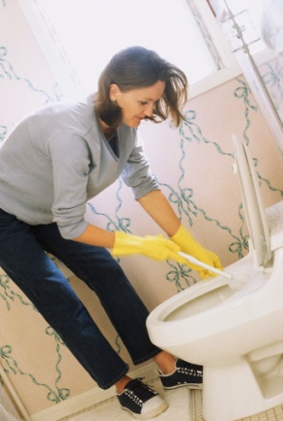
Where do we clean?
The short answer to this question is EVERYWHERE.
As a member of the cleaning team, you may be responsible for front of house areas or back of house areas or some of both.
Front of House is where all hotel guests and restaurant customers have access during their stay.
Back of House areas are where staff work and to where guests do not have access.

The following table is an example of Front of House and Back of House areas. All properties are different. Yours may have some other areas not mentioned in this table.
Front of House Areas
Driveways | Escalators
Entrances | Tennis Courts
Reception | Guest Stairways
Hotel Lobby Area | Emergency Exit Stairways
Car Parks | Business Centre
Garden Pathways | Hotel shops
Swimming Pools and Gyms | Public Toilets
Saunas, Spas and Massage Rooms | Cloakrooms
Covered walkways | Gaming Areas
Restaurants | Cinemas
Bars | Games Rooms
Public Lounges | Guest Laundry
Function Rooms | Guest Rooms
Corridors | Gaming Rooms
Guest Lifts | Special Features - e.g. Fountain, wall, tapestries, ponds

Back of House Areas
Staff Locker Rooms | Training Room
Staff Toilet Areas | Rubbish Compactor rooms
Uniform Issue Room | Recycling area
Linen Room | Back of House corridors
Hotel Laundry | Staff Accommodation (where applicable)
Staff cafeteria | Kitchens
Staff Lifts | Dispense bars
Storerooms | Cold rooms
Offices | Meeting Rooms
Tea Rooms | Loading dock

N.B. - In large hotels where there is more than one kitchen, kitchen cleaning is usually the responsibility of the Executive Chef who will have a team of cleaners or stewards under his direct control.
In small motels however the kitchen cleaning may be the responsibility of the Housekeeping department.

1.2 Identify work equipment to be cleaned and maintained

Introduction
In all areas of all properties there are many items and surfaces to be cleaned and maintained. It is important as a cleaner that you know exactly what items are to be cleaned and how.

Identify all items that will need to be cleaned
Considering all front and back of house areas previously identified we need to identify all items and surfaces in those areas that will need to be cleaned. This is a sample form on how to identify what is to be cleaned in each area.
LOCATION: HOTEL LOBBY  (FRONT OF HOUSE) | LOCATION: GENERAL MANAGER’S OFFICE  (BACK OF HOUSE)
Carpet | Carpet
Chairs | Chairs
Sofas | Desk
Coffee tables | Filing cabinet
Table lamps | Telephone
Upright lamps | Computer
Ashtrays | Rubbish bin
Glass doors | Desk lamp
Wall mirrors | Walls
Brass rails | Ceiling
Marble entry floor | Air vents
Telephone table | Picture frames
Telephones | Refrigerator
Picture frames | Coffee table
Wall lights | Flower vase
Window sills | Wall heater
Display cabinets | Cupboards and shelves
Walls
Ceilings
Air vents
Window coverings
Rugs and tapestries
Ceiling fan

Types of surfaces to be cleaned
Surfaces can be defined as soft or hard. Soft surfaces include carpets and curtains and hard surfaces include materials such as slate, wood, and steel.
Now that you have identified all items to be cleaned, we also need to identify what product each item is made of. The choice of material used will affect the choice of cleaning equipment and chemicals selected for use.
The table below illustrates some materials that may be used and what they may be used for.
MATERIAL | USES
Wool | Carpets
Nylon | Carpets
Wood | Floors and furniture, picture frames and wall panelling
Marble | Used in bathrooms on vanities and on walls and floors
Granite | As per marble
Brass | Used on taps, hand rails wall plaques and porters' trolleys
Glass | Doors, windows and mirrors
Slate | Used on floors
Ceramic (porcelain) | Used on bathroom fittings and floor and wall tiles
Terrazzo | Floors and walls
Clay tiles | Kitchens and bar floors
Leather | Furniture and decorative trims
Chrome | Used on taps, bath fittings, lamps and hand rails
Stainless steel | Sinks, taps and splashbacks. Lift doors, shower bases, ash cans and lamps
Concrete | Floors
Rubber | Floors and matting
Vinyl | Floors, furniture
Laminate | Drawers and furniture
Paint | Walls, floors ceilings and furniture
Plastic | Trays, tissue box covers, rubbish bins fridge, moulded showers and light fittings
Fabric | Upholstery, curtains, cushions and wall coverings
Wallpaper | Walls
Other metals - Silver, copper and brass | Decorations-bed heads, table frames

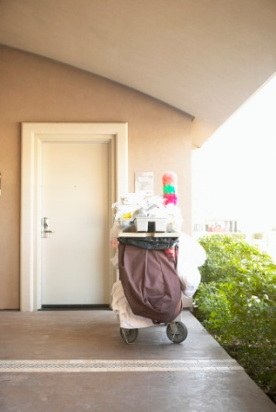
Frequency of cleaning
Once you have established which items and surfaces need to be cleaned, we then need to decide how often these areas will need to be cleaned.
The following terms must be understood when defining frequency:
- Daily clean - These are tasks that need to be done at least once daily. Some areas and items will need to be cleaned several times per day e.g. Public toilets
- Task of the day - The supervisor may instruct you on a specific task of the day that requires extra attention e.g. you may be instructed today to clean all door frames and their surrounds whilst tomorrow you may need to pay special attention to all chair legs. This ensures that all miscellaneous tasks are attended to, as and when needed
- Weekly clean - These are areas or items that need to be cleaned weekly. This may be scheduled on certain days of the week e.g. Monday - Clean the West Wing windows internally, Tuesday - Clean the East Wing windows internally, Wednesday - Clean lift grills on floors 8-14 on lifts 9 and 10
- Team Cleaning - This means that there will be a team of people each with their own task working in the same area at once e.g. In a public toilet area one person would clean all the toilet cubicles whilst another will clean all the wash hand basins followed lastly by somebody to clean all the floors. Team cleaning is rare in hotels but in large entertainment venues or offices, this practice is common. This will save all cleaners having to carry all pieces of cleaning equipment, instead just carrying the equipment they will need for their specific tasks
- Periodic cleaning - Tasks that are done on a regular periodic basis such as deep cleaning of carpets and upholstery, cleaning of chandeliers or windows. This cleaning will be planned and may involve at times using external contractors.
The frequency of cleaning will be determined by the amount of usage and patronage an area experiences.
- Example 1 - If a restaurant is open for breakfast, lunch and dinner, it will need to be cleaned after each meal time
- Example 2 - If a bar area is only open in the evening, it should only require one clean per day
- Example 3 - If banquet rooms are only in use on certain days or at certain times, they will need cleaning after each use.
- Example 4- A hotel lobby which is open 24 hours per day will require one major clean within that time (usually overnight) but will need regular maintenance cleaning throughout the day due to constant guest movements and activities.
- Example 5 - Public toilets will need to be cleaned at regular intervals throughout the day and night depending on guest movements and activities. If, for example, there are 500 women attending a conference, more attention must be given to maintaining the female toilets on a regular basis throughout the course of the conference.
- Example 6 - If a restaurant is open continuously over 24 hours, then it will be cleaned section by section during quieter times.

1.3 Identify and locate instructions in relation to cleaning and maintenance

Introduction
When working as a cleaner, you will need to have good knowledge of all the cleaning tasks assigned to you each day, where you will be working and how to operate the necessary equipment you will use. You will also need to know where you can access information about all aspects of your work if you are unsure.

What kind of information will I need access to?
In order for you to carry out your daily tasks, you may need information on:
- Where and what to clean
- How to complete each task
- How to complete a maintenance or hazard request form
- How to operate each piece of cleaning equipment that you will use
- How each cleaning chemical should be used and the risks associated with their use
- Knowing all safety aspects of your job
- Cleaners' log book.

How will you know where and what to clean?
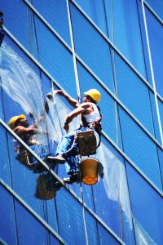
- When you start your shift, your supervisor will tell you where you will be working and what duties you will be expected to perform
- You may be given a written job schedule to remind and prompt you
- You may be asked to carry a pager or mobile phone so that your supervisor can contact you directly if there is an urgent need for cleaning in a particular area (e.g. a spill in the restaurant)
- There may be a log book in the cleaners' store which you should read and sign. This is a communication tool between cleaners and also from the supervisor to advise of "special events", complaints and items needing attention (shortages of consumables, vacuum cleaner not working).

What is a job schedule?
A job schedule is a written plan of where you should be cleaning with approximate times. It will also have a space for you to sign when certain tasks have been completed and a space for you to write down any problems or maintenance issues that need attention.
You should carry this with you on a clipboard and use it as a guide. On completion of your shift you should hand in the completed job schedule to your supervisor.
See sample below.
THE BANKS HOTEL
SAMPLE JOB SCHEDULE
SHIFT B (MALE) 11A.M. – 7.30P.M.
DATE_________________ NAME OF CLEANER_____________________________
AREA | TIME | SCOPE OF CLEANING | SIGNATURE
Gym & pool area | 11 am | Clean all toilets, urinals & basins, empty rubbish, replace soap & towels, wipe all paintwork, sweep & mop floors.  Mop and spot scrub all stairs to pool clean the showers & sauna.
All levels of car park including ramps | 1 pm | Check, pick up & sweep all rubbish, empty rubbish bins, wipe exterior of all lifts on all levels & sweep carpet, soak up any oil spills.
Loading bay | 3 pm | Check & sweep check rubbish is all in bins and & pressure wash the loading bay area
Deliver linen to floors | As linen arrives | -
Lobby/reception | 4 pm | Check & reclean as required
Male guest toilets level 6 & 14 | - | Check & reclean as required
Guest lifts | - | Check & reclean
Residential entrance | - | Check & reclean
Residential lift | - | Check & reclean
Floors 14 - 18 | - | Check & reclean .remove all rubbish, vacuum corridors
Gym & pool | 6.30 pm | Check & reclean as required

TASKS OF THE DAY
CLEAN ALL DAY BEDS AND CHAIRS AROUND THE POOL AND CHANGE ANY DIRTY CUSHIONS
_______________________________________________________________________
MAINTENANCE ISSUES
_____________________________________________________________________________________________________________________________________________________________________________________________________________________

What is a task description?
A task description is a written instruction of an individual task that will state all the steps and the procedures of each task and to what standard the task should be performed .It is used as a training tool so that all cleaners are trained in the same method for each task.
This sample task description sheet is for the cleaning of a urinal.
CLEANING A URINAL BOWL
STEP | PROCEDURE |  | STANDARD
Collect rubber gloves | Place on hands |  | To protect your skin from chemicals and bacteria
Collect cleaning equipment | Take into the bathroom and place on floor close to the urinal |  | To save time if close at hand
Flush the urinal | Push button |  | To remove any waste and to check the water flow
Remove any cigarette butts from urinal | Lift up strainer |  | To prevent blockages and smells
Select chemical | Pour the chemical around the bowl of the urinal |  | To sanitise the surfaces
Scrub urinal | With toilet brush all around |  | Check for water stains
Clean strainer | Scrub with brush and remove any hair |  | Free from all debris
Select chemical. Spray the exterior of the urinal including underneath and flush button | Wipe with separate cloth |  | To remove stains from all exterior surfaces and sanitise
Flush the urinal | Push button |  | To remove any residual chemical and rinse the surfaces
Dry off the urinal surfaces | Dry with clean dry cloth |  | To present a clean urinal
CHEMICALS NEEDED |  | EQUIPMENT NEEDED
Toilet bowl cleaner  All purpose detergent disinfectant |  | Toilet brush or swab  Toilet cloth  Dry polishing cloth
SPECIAL NOTE
Urinal cleaning cloths must be kept separate.
Toilet bowl chemical is acid and should NOT be used where there are marble floors to avoid damage. Ensure that toilet chemical is NOT in a spray bottle for safety reasons.
There should be a Task description for each cleaning task.

How will you know when to use a maintenance request form?
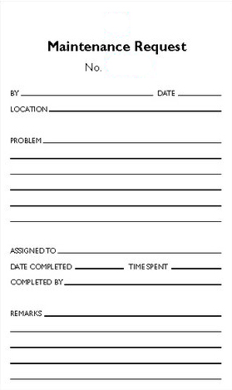
As you go about your work cleaning, you will find items not working as they should or you may find items broken either accidentally or deliberately by guests.
Examples of these may be light globes blown, loose hinges on doors, broken toilet seats or taps dripping. All of these things should be reported immediately by either submitting a written report to the maintenance department or via your supervisor.
If the matter is urgent (a blocked toilet or a broken mirror) then it is important to contact the Duty Maintenance technician by telephone to advise the matter is URGENT. Anything that has the potential to cause harm to another person is a HAZARD. This requires immediate action.
If you find that a vacuum cleaner is faulty, then it is YOUR responsibility to remove the item away from the work area so that it cannot be used by another cleaner. It must be reported and preferably have a brightly coloured tag placed on it to warn all staff that it is NOT to be used.
Find out from your supervisor how maintenance issues are reported in your workplace.

How do you know how to operate each piece of equipment?
Each piece of electrical cleaning equipment will have either an instruction manual or a task description sheet. If you have not been trained to use a certain piece of equipment, then you should tell your supervisor. NEVER use a machine that you are not trained to use. You could harm yourself, the item you are cleaning and you could also damage the machine through incorrect handling.
If you have been trained to use the equipment, the instruction manual or task description will remind you how to use it. Always refer to it if you are unsure or have forgotten.

How can I find out about the chemicals I use?
It is important when using chemicals that you know exactly what they were designed to do. Each manufactured chemical has a MSDS (Material Safety Data Sheet). This piece of paper will tell you everything you need to know about all safety aspects of each chemical you are using.
Each chemical will also have a technical bulletin. This will tell you what purpose each chemical is for, e.g. cleaning windows, and at what dilution rate it is to be used.
Chemical companies also provide coloured wall charts which can be hung on the wall in the cleaners' store room. This will have pictures and diagrams and each chemical noted on these charts should match the labels on the spray bottles.
Both sets of bulletins should be stored in a waterproof folder close to where the chemicals are stored so everybody can read them.

Knowing when to clean
In order to clean at the right time, you will need to know the operating hours of all restaurant, bars and function rooms. The table below is an example of a possible trading roster around which your job schedule will be planned.
The London George Hotel
NAME OF AREA | OPERATING HOURS | DAYS OF THE WEEK | SERVICE
Ricardo's Restaurant | 7p.m. -1.00a.m | Tuesday - Saturday | Dinner only
Café 94 | 6a.m.-1.00a.m. | Monday - Sunday | Breakfast, lunch and dinner and coffees all day
Gypsy Lounge Bar | 12 noon -12 midnight  12 noon -8p.m. | Monday - Saturday  Sunday | Coffee, snacks, afternoon tea and bar service
White Swan Bar | 12noon -8p.m. | Tuesday - Saturday | Bar service only
Pool Café | 10a.m.-6p.m.  12 noon -6p.m. | Monday - Saturday  Sunday | Soft drinks only
Lucky Mouse Restaurant | 12noon -3p.m.  6p.m.-12midnight | Monday - Sunday | Chinese restaurant
Pacific Club | 7p.m.-3a.m | Friday - Sunday | Night club
The Parlour | 24 hours | Monday - Sunday | Snacks and drinks, light meals
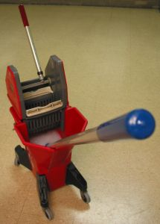
Regular daily cleaning will be planned around these operating times. Your job schedule should reflect this.
Using the above example, Café 94 would have the major clean between 1a.m and 6a.m when it is closed .Minor cleans will be completed between meals i.e. after breakfast and after lunch.

Sample of a daily function schedule:
HOTEL RAGUSA
FUNCTIONS TO BE HELD ON FRIDAY MAY 21ST 2012
NAME OF FUNCTION | TYPE OF FUNCTION | TIME OF FUNCTION | FUNCTION ROOM | FINAL NUMBERS
Training for Professional Managers | Breakfast seminar | 07.30-09.30 | Blackwood 1 & 2 | 250
Business Law Education Centre | Seminar | 08.00-14.30 | Blackwood 3 | 25
Care members update | Luncheon | 12.00-15.00 | Elizabethan Room | 70
Westgarth Grammarians | Luncheon & Presentation | 12.00-16.00 | Victoria Suites | 45
Rogers and Johnson | Product Launch | 14.00-18.00 | Blackwood 1 & 2 | 190
Sunflower Baseball Team | Annual General Meeting | 18.00-22.00 | Elizabethan Room | 80
Mantrax Pest Control | Annual Dinner and Dance | 18.00-02.00 | Tower Ballroom | 500
Daily cleaning will be planned around this schedule. This function list will change daily so cleaning will be planned the day before.
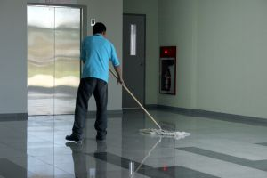
Using the above example Blackwood Rooms 1 & 2 would require cleaning between the hours of 0930 and 1400hrs and again between 1800hrs and the next morning.

Work Projects
It is a requirement of this Unit you complete Work Projects as advised by your Trainer. You must submit documentation, suitable evidence or other relevant proof of completion of the project to your Trainer by the agreed date.
1. Compile a list of all areas both front and back of house that require cleaning. Include the types of both soft and hard surfaces that you would have to clean.
2. Design a task description for cleaning an elevator.

Summary

Identify cleaning and maintenance requirements
Understand what is meant by cleaning
Understand what is meant by maintenance
Identify all areas that require cleaning, including front of house and back of house
Identify all items that require cleaning
Recognise different types of surfaces
Understand the frequency of cleaning
Identify and locate all instructions in relation to cleaning
Understand a job schedule
Locate task descriptions
Locate the necessary maintenance and hazard request forms
Locate all operating instructions for all cleaning equipment
Read a trading roster and banquet schedule.

Element 2:
Clean industrial work areas

2.1 Assess area to be cleaned


Introduction
Before you attempt to clean an area, there are several considerations that need to be made. You need to understand the scope of cleaning that is required, at what time you will be able to clean an area and the equipment and chemicals that you will need to complete the job.

The scope of cleaning
The scope of cleaning refers to the amount of cleaning that will be required to be done at each clean i.e. which surfaces and items and to what extent.
- Example 1 - In a restaurant that is open for breakfast, lunch and dinner, the major clean of the restaurant would normally be done overnight or early morning when the restaurant is closed. In this case all surfaces requiring to be cleaned will be done. This may include the cleaning of all chairs, tables, sideboards, walls, vacuuming and spot cleaning of the carpets, hard floors swept and mopped and glass surfaces polished
- Example 2 - in the same restaurant, between meals cleaning may only include the spot vacuuming of carpets or where there is mess (spillages and crumbs ) and spot cleaning of glass doors
- Example 3 -In the same restaurant, if the carpet is required to be deep cleaned because it is extremely dirty, this may be scheduled as required or on a regular periodic basis
- Example 4 - In back of house office areas the daily clean may only include the emptying of rubbish bins and removal of waste but that desks are cleaned and the carpet is vacuumed only twice per week.

The timing of the cleaning
The timing of the cleaning refers to the time when you can clean an area and also how long you have to clean it.
- It is vital that consideration be given to when cleaning may take place e.g. the cleaning of the Reception area should not be carried out when guests are checking out in the morning and there are large numbers of people and suitcases in the lobby. This would be very unprofessional and would also be inconvenient to all parties. Imagine if a noisy vacuum cleaner is being used near the desk whilst the reception staff are trying to talk to guests!
- It is important that cleaning staff be as inconspicuous as possible at all times whilst they go about their cleaning tasks. You should never clean within three meters of a guest.
- In restaurants bars and banquet rooms, cleaning should be planned around the Food and Beverage departments trading roster and the Banquet department's daily function schedule.
- During periods of slow trading additional periodic cleaning may be planned.
- If an area is to be refurbished (e.g. bar) and therefore closed for an extended period of time there must be planned cleaning when renovations are complete and before the area is re-opened for use.

Factors that can affect timing
On occasions, there may be times when you go to clean an area as planned but it is not available for you to clean. The reasons may be:
- A function may be running over time and guests have not yet departed. In this case you may need to return several times to see if this area is ready to be cleaned. If the function is running very late and the timing will delay your cleaning another area, you must tell your supervisor who will then instruct you
- The maintenance department may be conducting emergency work due to a fault or complaint. If they are using ladders or heavy equipment and you cannot access the area for cleaning you should ask them to let you know when they have finished their work so you can return and clean later
- The area may have been damaged by guests deliberately or by accident. In this case you MUST notify your supervisor who will advise you what to do. If the damage is deliberate (graffiti on toilet walls or broken fittings), there may be a need for your supervisor to alert security staff or the police. Clean-up must only be done after a thorough investigation.

Accessing an area
As a cleaner you have a clear responsibility for security in the areas that you clean.
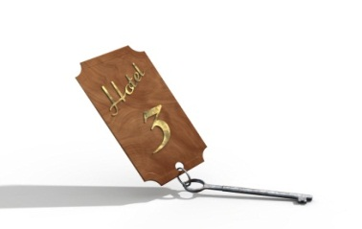
Keys
- In a hotel or entertainment venue, many areas that you clean will be readily available to clean at most times. Should you work on the overnight shift or at weekends when some areas will be closed, you will need to have access to certain keys in order to unlock and lock up when you have completed your cleaning tasks
- It is important that you keep the keys with you at all times. Keys are often worn on a belt around the waist or attached to a large key tag so that they cannot be easily misplaced. ALWAYS keep the keys on your person and NEVER leave them lying on cleaning trolleys or hanging from door locks. To do so may compromise security within the property
- You may be asked to sign for keys when you collect them from the Housekeeping office, Reception or Security staff
- NEVER lend keys to other people and NEVER open areas for people you do not know
- In some properties you may be instructed to lock the doors when you are inside an area cleaning. This is for your own personal safety.
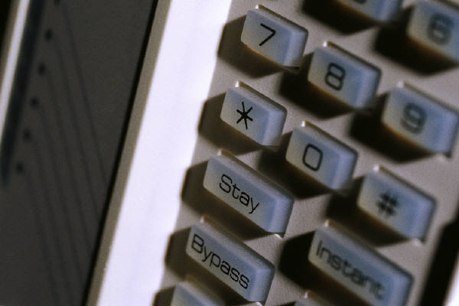
Alarms
- Some areas of the property may have alarms set when closed at night. It is important, when accessing an area that is alarmed, that you know the correct procedure for disarming it or who to call to disarm it for you
- If you access an area and the alarm goes off in the middle of the night, it may disturb other guests.
Lights
- Many entertainment venues and hotel facilities may use "mood lighting" when they are open to create ambience and warmth. These are not usually bright enough to facilitate easy cleaning. Most venues are equipped with "Cleaners' lighting" which is much brighter and makes it easier to see what you are cleaning
- You should know the location of all light switches for when you are cleaning

- These must be switched off when you have finished and mood lighting reset if necessary.
Lost Property
- When cleaning in all areas, you may find items that have been left or dropped by guests and staff alike. If you find umbrellas, sunglasses, briefcases or items of clothing, it is important that you hand them in when found. Always follow the lost property procedure in your workplace
- Handing in lost items will help to maintain the reputation of the hotel when guests are reunited with their property
- When cleaning office areas, only remove rubbish that is in the rubbish bin. On occasions you may find documents on the floor which may have simply been dropped
- Never remove items from desks - simply lift and clean.
Reporting Unusual Activities
- It is not unusual in licensed venues to have incidents that can compromise both safety and security to other parties. You may encounter drunk or drugged guests during your work and it is VITAL that you report any suspicious activities or incidents immediately. You should never place yourself in danger - always walk away from a difficult situation or if you feel uncomfortable
- If you discover an area that has been vandalised or is in an unusually dirty state, then you MUST report these issues as soon as possible before attempting to clean.
Now that you understand the scope of cleaning, the timing of cleaning and how to access an area, it is important to now identify the types of soil you will be cleaning.
For general cleaning purpose, the soil you will encounter will be:
- Litter - this is highly visible and consists mainly of paper items; newspapers, drink containers, food wrappings, tissues, cigarette butts
- Dust - this is a mixture of all things that are airborne and can include lint, sand, ash, and feathers. Dust is present on all surfaces both horizontal and vertical
- Dirt - this is primarily a grease base mixed with dust
- Staining. This is an unwanted product which changes the appearance of a surface either temporarily or permanently
- Tarnishing. This is a reaction of metal to the atmosphere - iron produces rust , brass goes very dull and copper produces a green residue called verdigris.
The type of soil that you are cleaning will affect the chemicals you choose for cleaning.
Different cleaning methods
Cleaning is usually done in several ways:
- Mechanical - by machine or human action or both
- Chemical
- Combination of both mechanical and chemical
- Heat and Steam (sterilisation).
Examples of cleaning methods
Mechanical action (Machine ) | Mechanical action by man | Mechanical + Chemical | Notes
Vacuuming | Vacuuming | None | -
Polishing | Hand Polishing | Polishing | -
Washing | Hand Washing | Washing | -
Scrubbing | Hand Scrubbing | Scrubbing | -
Dry Cleaning | Dry Cleaning | Dry Cleaning | -
Hot Water Extraction | Hot Water Extraction | Hot Water Extraction | -
Stripping and Sealing | Stripping and Sealing | Stripping and Sealing | -
Sweeping | Sweeping | Sweeping | May need sweeping compounds.
- | Wet mopping | Wet mopping | -
Spot cleaning | Spot cleaning | Spot cleaning | -
Pressure washing | Pressure washing | Pressure washing | Does not always need chemicals

2.2 Select appropriate cleaning equipment and chemicals

Introduction
Now that you understand where you may be cleaning, what you will be cleaning and when you will be cleaning, you now need to know which cleaning chemicals and equipment you will need to complete all the tasks.

Selection of cleaning equipment
Cleaning equipment covers a wide range of products and items. The following information is to help you decide which machine you may need to use.
Electrical equipment may cover:

Vacuum cleaners
The vacuum cleaner is the most used piece of electrical cleaning equipment. If it is properly cared for it will become your best friend!
How does a vacuum cleaner work?
The purpose of a vacuum cleaner is to collect all small pieces of litter and dust which is embedded in the carpet. A vacuum cleaner is powered by a central motor which drives a fan creating suction. The strength of suction is dependent on the power of the motor. They have a combination of filters which collect the dust and prevent it from being recirculated into the atmosphere. The primary filter is the dust bag which can be either made of fabric or paper which is disposable.
There are many different styles.
Upright models
These are used by pushing backwards and forwards over the carpet.
- Older styles of upright models have one motor which drives a belt which rotates the brush at the front. The brush lifts the pile and the suction action, draws the dirt into the bag
- More modern models have two motors, the main motor drives the fan and the second motor drives the brush which rotates and sweeps the carpet as well as helping to lift the pile
- The brush height can be adjusted for different types of carpets
- The switch is usually located on the handle but can also be foot operated. There is also a secondary pedal for lowering the handle making it easier to use
- On the upright model, the bag is the primary filter. This may be made of fabric with a paper insert or the paper bag may be enclosed inside a plastic housing
- Many models have an indicator light to alert the operator when the bag is full
- They are available in different sizes and are ideal for vacuuming large areas of carpet. Some models can actually pick up articles as large as a paper cup
- They are available in different widths. The wider they are, the bigger the area that can be cleaned in the shortest amount of time
- They are lacking in that they are unable to vacuum right to the edge of a carpet although more recent models have an on board hose attachment which can be used for this purpose.
Barrel style
The barrel vacuum cleaner is named because of its appearance. They are usually on wheels with a flexible hose and have extension tubes with a nozzle attached. The nozzles can be interchanged for different surfaces e.g. a brush nozzle would be used on hard floor, where a flat nozzle would be used on carpet.
The switch is located on top of the barrel. The motor is attached to the base by clips and is removed when the vacuum cleaner needs to be emptied. Most vacuum cleaners have a paper bag but many are also used without the bag. When there is no paper bag the secondary filter will block more easily and this will cause the vacuum cleaner to age prematurely and becomes very messy to empty.
Canister
Canister vacuum cleaners are similar to barrel vacuum cleaners but they are cylindrical in shape.
Wet vacuum (picks up water only)
The wet vacuum cleaner basically operates in the same way as a barrel vacuum cleaner. The main difference is that inside the vacuum cleaner, the motor is protected by a hard plastic cover to which is attached a "ballcock" The ball rises with the water level and when the vacuum cleaner is full, the ball will switch the machine off to alert the operator that it needs to be emptied.
The hose is made of a flexible plastic and the attachments may have a brush or two squeegees attachment. (A squeegee is a rubber blade.)
These vacuum cleaners can be used if there is a water leak or to pick up water after hard floor scrubbing.
N.B. -There are some machines which can be used for both wet AND dry purposes. However, extreme care must be taken to ensure that the internal filters and attachments are changed prior to operation. Failure to do this may result in damage to the machine and could compromise safety to the operator.

Backpack
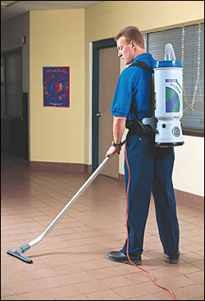
This is a vacuum cleaner where the body of the machine is carried on the back. It is worn like a backpack and is strapped to the operator by straps and buckles. They are designed to be used in areas where access is difficult e.g. in cinemas and theatres between all the seats or in restaurants where there is a large amount of tables and chairs. They can be heavy and hot if worn for an extended period. They are designed to be used on curtains and air vents and periodically on carpets. The size of the machine limits the amount of suction that is generated. They should not be used by people who have bad backs.
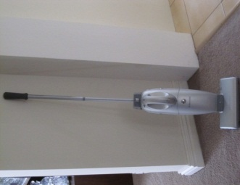
Stick vacuum
This is a small vacuum cleaner that is battery operated .The vacuum cleaner is attached to a charger when not in use. Its use should be confined to cleaning up small spillages e.g. sugar bowl in the restaurant during service and where noise is a consideration. (Near to guests)
Hand held
The hand held or "dustette" is similar to the stick vacuum in that it should be used in emergencies for small spillages. Whilst most are designed for dry pick up, some can pick up liquids too. The dust holding capacity is extremely small.

Floor scrubbing machines
A floor scrubbing machine is used for wet scrubbing on hard floors. They vary in sizes and the machine can be either manually operated or automatic.
- The manual scrubbing machine requires the floor to be mopped first with wet cleaning solution and then scrubbed with the machine using a bristle brush. The wet solution can either be mopped away with clean water or suctioned with a wet vacuum. Some models have a tank on the upright from which the cleaning solution is dispensed by the operator.
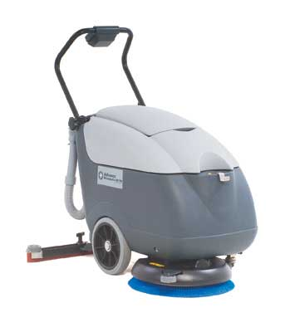
- The automatic scrubbing machine has simplified this method of cleaning as the machine wets, scrubs and suctions in one pass. Inside the machine there are two tanks - the first has the cleaning solution and the second tank is empty. The operator uses the switches and controls located on the handles and dispenses the cleaning solution. The brushes then scrub the floor as the machine moves forward. At the back of the machine there is a squeegee attachment which then passes over the clean floor and suctions up the dirty cleaning solution in to the empty tank. This makes large hard floor cleaning more efficient.
These machines can be propelled by pushing or they can be large enough to ride on. The larger ones are used in large shopping centres or car parks.

Floor polishing machines
Polishing machines are used as the name implies for the polishing of hard floors such as vinyl, cork and marble. They are single disc machines used in conjunction with brushes, floor pads, floor strippers and polishes according to the task at hand.
These machines can be used to strip, polish and buff floors. The speed at which they rotate creates heat which hardens the floor polish creating a high gloss shine sometimes described as a "wet look”. All machines are different but generally they rotate between 150 and 650 rpm (revolutions per minute) depending on what they are to be used for. These are classified as slow machines.
Many polishing machines are used in a side to side or "swing" motion. The handle is lowered to move left and raised to move right.
High speed polishing machines (up to 2500 rpm) are known as burnishers but can only be used to polish floors. They are used in areas where there is a large amount of floor space to be polished. Most operate in a straight line rather than side to side and are easier to handle.
Some machines may have a vacuum attached so they can polish and pick up dust at the same time.
All machines should have a protective skirting around. This helps to protect walls and furniture as well as protecting them from chemical splash.

Carpet cleaning machines
There are many different ways of carpet cleaning and therefore many different styles of machines.
Rotary shampoo machine
This is an upright machine which has a tank on the upright. This tank holds the cleaning solution which is dispensed by the operator using the controls on the handles. The cleaning solution is dispensed down a tube through the brush and the operator drives the machine in a straight line from left to right and then back again. The machine can have just one round brush or three smaller brushes (usually nylon) on the rotating head. The operator must be well trained in its use as too much scrubbing of carpets may damage the fibres. The mechanical action of the brush loosens the soil. This method is not recommended for shag pile carpet as the pressure tends to flatten the pile. The area must be left to dry preferably overnight and the carpet will need to be vacuumed the next day to remove loose carpet fibres and lift the pile. Resoiling of the carpet recurs quickly as detergent residue remains in the carpet.
Dry Foam Shampoo machine
This machine is useful where noise may be an issue and where quick drying is required. It is similar to the rotary shampoo machine with the exception that the brush rotates forward instead of in a rotary motion. The chemical used is designed to produce a high foam which absorbs the soil loosened by the brush and then dries as a powder which must be vacuumed when the carpet is dry. Drying time is minimal (two hours).
Hot water extraction
This method is often referred to incorrectly as "steam cleaning".
Of all the carpet cleaning methods, this one is probably the best. The machine is designed to deep clean the carpet. There are two tanks inside the machine. The first one holds the cleaning solution and may also have a heating element. The cleaning solution is injected under pressure into the fibres of the carpet through a hose where it "massages" the fibres removing the soil. The operator then suctions the dirty cleaning solution from the carpet into the second tank which is known as the recovery tank.
These procedures are all done with the use of a triangular attachment which is known as a wand or drag tool. There may be a smaller wand attachment which can be used for cleaning upholstery or the cleaning of carpeted stairs.
In the most recent models of hot water extraction machines, the wand is attached directly to the front of the machine. This does save time in the set up of the machine prior to use.
This method of cleaning requires a skilled operator as too much water may lead to the carpet rotting or water that is too hot may shrink the carpet. The operator works in a backwards motion, section by section and each action should be overlapped so that the carpet does not dry streaky. Approximately 70% of the water is extracted from the carpet. The carpet should be left to dry for approximately eight hours if possible before the area is re-used.
N.B - This machine can also be used as a wet vacuum cleaner if necessary by just using the suction function.
Bonnet cleaning
This method of carpet cleaning is often marketed as dry cleaning of carpets. This is not really true as water is used.
The bonnet is a very soft floor pad with long fibres. It may be made of cotton or a cotton polyester blend. It is used on a rotary floor machine attached to a special pad holder.
The carpet may be pre-sprayed with a cleaning solution if very heavily soiled. The bonnet pad is dipped in to the cleaning solution and lightly squeezed. It is then placed onto the rotary machine and the machine is passed over the carpet similar to the method described above for the rotary shampoo machine. The pad must be continuously changed as it will absorb dirt from the carpet.
Once cleaning is finished a clean dry pad is used on the machine to help dry the carpet. The area must be well ventilated as the cleaning solution is a solvent cleaner and does leave a smell which may be offensive to some people.

Upholstery cleaners
The hot water extraction machine as mentioned may have attachments that can be used for upholstery and stairs cleaning. A portable spotting machine may be used also for cleaning upholstery. This is a small machine which can be carried like a suitcase or on a shoulder strap but is in essence a small hot water extraction machine. These can also be used for carpet spotting.
There are rotary dry foam upholstery shampoo machines which are small and portable.
Care must be taken when cleaning upholstery to examine the care label. Some fabrics may only be dry cleanable.
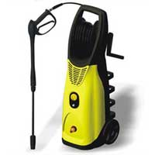
High pressure washers
Pressure washers are also known as jet blasters. They are connected to both a water outlet and a power point. They have a long hose which may have several attachments for different cleaning purposes. As water flows through the machine it is pressurised through high pressure pumps and when the spray trigger is squeezed the water is forced under great pressure on to the surface. The water pressure will dislodge the dirt. They are very good for cleaning heavily soiled pathways and walls. Detergent may be added to the water by way of a detergent feed.
Steam cleaners
Steam cleaners work similarly to high pressure washers except that they deliver steam. They clean and sanitise at the same time and are excellent for use in areas where hygiene is important e.g. kitchens and bathrooms. They vary in size and are available with many different attachments. They are excellent at removing mould in bathrooms and heavy deposits of grease in kitchens. No chemicals are used with these.
Care must be taken in their use as steam can burn.
Portable dryers
These are portable electrical blowers which circulate the air at room temperature under great force. They are used to dry wet floors and are particularly helpful when drying carpets where areas have been flooded.
Blowers
Blowers are used outside to blow leaves and litter to a central point for pick up. Some may also have a reverse action and can then vacuum up all the leaves and litter into a bag which is connected to the blower.

Other heavy cleaning equipment may include
Outdoor sweeping machines
Sweeping machines can be manual or battery driven. They are used to pick up litter and leaves. They may be useful in car parks, driveways or in workshops. Small area sweepers involve the operator walking behind whilst pushing the machine. A brush located on the side rotates and brushes the debris into a hopper which is easily removed for emptying. The hard bristle brush can be adjusted to get into small corners.
Larger machines may be battery driven and others may be ride on. These larger ones are used for street sweeping.
Carpet sweepers
These are used only for small clean up tasks (e.g. ashtray dropped). These are manually operated and sweep up the debris into a hopper which is then removed for emptying.

General Cleaning Equipment may include
Trolleys
Cleaning trolleys come in all different styles and sizes. If the cleaning that you undertake is far from the cleaners' store or involves many different tasks, then a well organised trolley will make your job easier and you more efficient. Trolleys should be as inconspicuous as possible when cleaning and because they are seen by the guest should always be neat and tidy.
They should be stocked with:
- Cleaning chemicals
- Cleaning cloths
- Garbage bags
- Bin liners
- Toilet rolls
- Paper towels
- Soap refills
- All necessary cleaning equipment for the tasks being undertaken (mops and buckets)
- Wet floor signs
- Scourers
- Tongs.
If the trolley is correctly stacked and maintained, then you will save time and energy as you will be more efficient because everything is close at hand.

Buckets
You will need a variety of buckets to complete different tasks. Buckets can be made of plastics and metals. There are single buckets and double bucket systems. You may have a bucket purely to hold all your cleaning chemical bottles in or a special long low bucket for window cleaning.
Whichever type you use, they must have a strong handle and be heavy duty. Metal buckets may rust over time and leave marks on the floors you are cleaning. Castors may break as may the mop wringer. Never use a faulty bucket as you may hurt yourself.
Colour coded mop and bucket systems may also be used i.e. Red for toilets, Yellow for kitchens, Blue for floor polish. Always make sure that the correct colour is used in the right area. This is to prevent cross infection and also to stop grease from kitchens being transferred to marble floors for example.
Separate single purpose buckets should be kept specifically for stripping floors and polishing floors and marked accordingly.
Double bucket systems are used for mopping and rinsing a floor. One bucket has the cleaning solution and one has clean water for rinsing.
Mops
Always choose the right type of mop for the task you will be doing. There are cotton mops, cotton/polyester blends, sponge mops, dust mops and microfiber mops. Cotton and cotton polyester blends come in different weights. Female staff may use a lighter one than a male. Cotton mops are used for mopping as they are more absorbent and cotton/polyester ones are used for applying polishes to hard floor because they are lint free and so do not leave particles. Microfibre mops do not require the use of any chemicals. Sponge mops are not recommended for commercial heavy cleaning as they disintegrate quickly.
Rakes
Rakes can be used for collecting leaves in outdoor areas but they are often used on carpet to collect large amounts of litter (after parties when there may be streamers and balloons) or after wet cleaning of long pile carpet to lift the pile. Specially designed carpet rakes also exist.
Brooms and Brushes
Brooms are available in different widths and with different bristle types. Soft bristle brooms are usually better on indoor hard floors and hard bristles better on outdoor areas.
The wider the broom, the larger the area that can be swept in one pass.
Brushes and brooms are used for:
- General sweeping
- Toilet cleaning
- Cobweb removal
- Dishwashing
- Hard floor scrubbing
- Shoe cleaning
- Painting
- Bottle washing
- Upholstery brush (called a whisk broom).
Toilet brushes
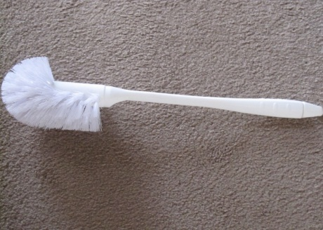
Toilet brushes are made in different sizes and styles. Choose one that has a strong handle and can reach all areas. You MUST always keep the toilet brush separate from other cleaning tools and cloths and you should replace it regularly for hygiene reasons.
The one pictured is a Turks Head brush. Note the bristles on the top. These are designed specifically to clean under the rim of the toilet which is the dirtiest part of a toilet bowl.
Feather dusters
Feather dusters can be made of pure ostrich feathers which are very expensive or synthetic feathers. Other long handled dusters can be made of lamb’s wool. These are used for dusting high areas and can be bought with an extending handle to reach those areas.
Squeegees
Squeegees are a rubber blade on the end of a handle and are used for pushing water towards a floor drain or for cleaning windows.
Floor Pads
Floor pads are used on floor machines. The standard size is 40 cm diameter. The darker the colour, the coarser and more abrasive they are.
- Black and brown are used for stripping polish off floors
- Red for general cleaning
- Blue for buffing
- White for polishing
- Lamb's wool for polishing.
N.B. - Burnishing machine pads are pastel in colour light tan or pink
Scourers
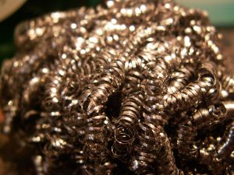
Scourers are nylon or polyester pads similar in texture to floor pads but are thinner and are used by hand to clean stubborn marks. Green and white are the most common ones used in general cleaning. They should not be used on plastics or flat paint as they will scratch (these are abrasive). They can be attached to a plastic hand held holder and used for scrubbing or to a long handled one for floor or high cleaning.

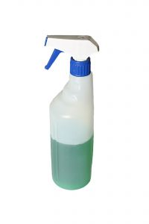
Spray bottles
Spray bottles are used to hold cleaning chemicals. They should be correctly labelled with a waterproof label and the spray nozzle should always be in good working order. They should be made of a translucent material for visibility.
Window cleaning equipment
Window cleaning equipment may include
- Lamb's wool cover
- Applicator
- Scaffolding
- Bosons chair
- Squeegee
- Telescopic handles and poles
- Ladders
- Cloths
- Long low bucket.
Cleaning Accessories may include:
- Ladders
- Garbage bags
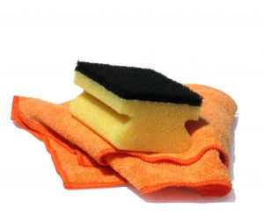
- Rags and cleaning cloths
- Paper products-toilet rolls and paper towels
- Soap refills
- Bin liners
- Scouring pads
- Extension leads
- Roller towels
- Sanitary bags.

Selection of Cleaning Chemicals

Introduction
When selecting cleaning chemicals, ALWAYS try to restrict the number to a minimum. Cleaning chemicals, if used properly, make your job easier but, if not ,can be both hazardous to your health and damage surfaces that you clean. It is important that you understand all aspects of each one including what they should be used for, and the safety precautions to take.
Firstly, determine:
- The cleaning tasks to be done
- The types of surfaces to be cleaned
- Consider the safety of using every chemical
- The ability of the chemicals to do the job required
- The smell of the chemical should be pleasant and fresh
- Labelling of containers. The quality of the label is important so that the instructions do not wash off and are clearly visible at all times
- Consider how the chemicals are dispensed and stored. If large drums have to be decanted, this may be dangerous. Most chemicals now can be purchased in concentrated form and used in conjunction with an automatic dispenser attached to a cold water supply. This is calibrated to the correct dilution rates.
Cleaning is a science and knowledge and understanding of cleaning chemicals is vital. You should have a basic understanding of the ph scale. The ph scale measures the intensity of acidity or alkalinity of a product.
pH Scale
More Acidic |  |  |  |  |  |  |  |  |  |  |  |  |  | More Alkaline
Hazardous |  |  |  |  |  |  |  |  |  |  | Neutral |  |  |  | Hazardous
1 | 2 |  | 3 |  | 4 |  | 5 |  |  | 6 |  | 7 | 8 |  |  | 9 | 10 |  | 11 |  | 12 |  |  | 13 |  | 14
Toilet  Cleaner |  |  |  | Acetic Acid  Vinegar |  |  |  | Metal Cleaners |  |  | Carpet Shampoos |  |  |  | Bleaches |  |  | Soap |  |  |  | Alkalis |  |  | Heavy Duty Cleaners
Hydrochloric acid - concentrate |  |  |  | Citric Acid  Lemon Juice |  |  |  |  |  |  | Germicidal |  |  |  |  |  |  | Ammonia |  |  |  | Grease Removal Agent
Oxalic acid |  |  |  |  |  |  |  |  |  |  | Dishwashing Liquid |  |  |  |  |  |  | Toilet Soap |  |  |  | Caustic sodas
 |  |  |  |  |  |  |  |  |  |  | Window Cleaners |  |  |  |  |  |  | Soap Flakes
 |  |  |  |  |  |  |  |  |  |  | Aerosol Sprays
 |  |  |  |  |  |  |  |  |  |  | 80%

Cleaning chemicals are classified in the following categories
Acids
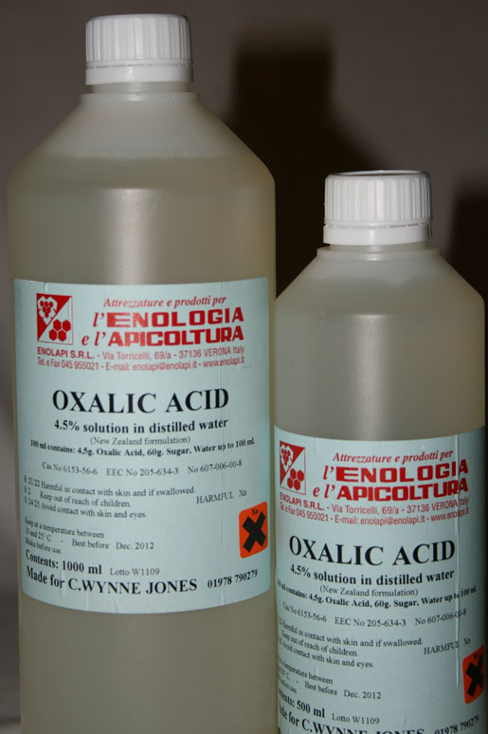
An acid is a substance that is soluble in water with a pH level of less than 7. All acids should be handled with extreme care as they are corrosive to surfaces if used incorrectly and may damage your health. They should never be used where there is a marble floor as they may leave permanent stains or even dissolve the marble. Acids can BURN and cause disfigurement if used incorrectly.
Acids include:
- Rust removers such as Oxalic acid
- Hydrochloric acid which can be used on very old and stained toilet pans but is extremely corrosive and should only be used in extreme circumstances. It may be used as a periodic "deep clean" for urinals where there is a residual smell. Breathing apparatus and rubber gloves should be worn when handling
- Toilet bowl cleaners which include phosphoric acid. Wear gloves at all times
- Vinegar (Acetic acid) can also be used to clean toilets and is less harmful to the user.
Toilet bowl cleaners are available in liquid, powder, and crystal form and are designed to remove lime scale and urine stains and to kill bacteria that cause smells. They have a thickener added which helps the chemical ‘cling’ to the bowl.
N.B - Never mix acids with chlorine bleaches as this reaction will create chlorine gas which, if inhaled, can be fatal.
Abrasives
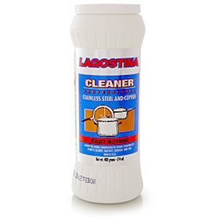
- An abrasive detergent cleans by scratching. Abrasives are available in paste, powder and liquid form. The abrasive that is used will affect the colour of the product. The abrasives used may be sand, pumice or marble. Salt is also an effective abrasive if mixed to a paste with lemon juice
- Abrasives are used on heavily soiled surfaces in bathrooms, kitchens and tarnished metals
- Abrasives should be used sparingly as continual use will degrade a surface over time making it harder to clean
- Abrasives may also contain solvents to help remove grease, chlorine to whiten and silicone to form a protective coating after cleaning
- Abrasives should not be used on certain surfaces like flat paint, plastics, glass and wood as they will surely damage the appearance of the surface. They are used mainly on ceramic surfaces in bathrooms or on stainless steel
- If they are used in toilets to remove stubborn stains, then always make sure that they are soluble in COLD water
- Abrasives may leave a white film on surfaces which need to be well rinsed away
- Abrasives will over time remove the metal from plate metals.

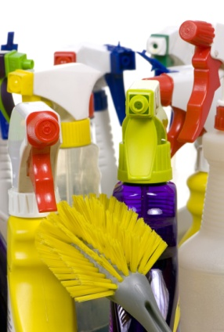
Detergents
- Technically all cleaning chemicals are detergents as the word is derived from the Latin word “detergere” which means to clean off
- Detergents used for cleaning are usually synthetic and are a by-product of petroleum i.e. they are manufactured in a laboratory and they are designed by chemists for specific cleaning tasks
- They are usually slightly alkaline as they are designed to remove soil which is acidic in nature
- Detergents are usually mixed with water at different dilution rates in order to penetrate the soil and hold it in suspension until it can be rinsed away
- Synthetic detergents have largely replaced the use of soap because unlike soap they have a high tolerance to hard water and can be efficient at all temperatures. Soaps can leave a scum film when used with hard water which can be re-deposited on the surface that is being cleaned
- Detergents can be formulated for different uses e.g. hand dishwashing, machine dishwashing, laundry and floor cleaning
- Some may produce a high foam (hand dishwashing) and others a low foam (carpet cleaning detergents)
- Detergents may contain optical brighteners, water softeners, dyes and perfumes and bulking agents (a bulking agent makes a liquid detergent thicker)
- Window cleaners may contain alcohol for quick evaporation
- All purpose general cleaners may contain solvents and ammonia.
Alkalis
- An alkali is a product that has a ph level higher than 7. Alkalis are caustic and corrosive in nature and are HAZARDOUS to the user if not used correctly
- They are used for the removal of heavy grease and proteins such as drain cleaning, oven and grill cleaning and car park flooring where there may be deposits of oil and as floor polish strippers
- They are available in powder or liquid form
- The main active ingredient is caustic soda (or sodium hydroxide)
- Their use should be kept to an absolute minimum to reduce risk.
Bleaches
- Bleach is present in many cleaning products. Bleach is not a cleaner but does kill germs
- The distinctive smell it gives off gives the impression of cleanliness. It works by changing the colour of a stain as in toilet bowls or urinals. The main bleach used for this purpose is sodium hypochlorite
- Bleach is very unstable and if it is stored incorrectly will soon become ineffective
- It should never be used on carpets or fabrics as it will change the colour of the fibres
- Accidental spillages can cause damage to surfaces
- Its use should be minimised.
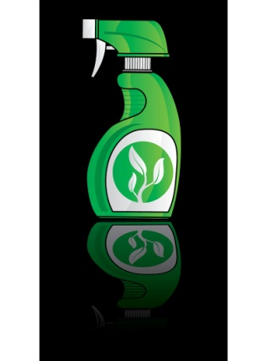
Disinfectants
- Disinfectants render pathogenic (disease producing) organisms inert. Disinfectants used in the hospitality industry are generally called broad spectrum disinfectants. This means that they kill most bacteria with the exception of spores and viruses
- Whilst good cleaning practices will remove many bacteria it should be noted that disinfectants are not good cleaners. They may be formulated with a detergent by the manufacturer but if not you should NEVER mix a disinfectant with other chemicals as you may make the disinfectant ineffective
- Disinfectants need time to work and will need to be rinsed off surfaces. They should be used on all surfaces that are exposed to body fluids. e.g. toilet seats and fittings
- Disinfectants are used primarily with hot water which increases their effectiveness
- Hospital grade disinfectants are known as germicides and will kill pathogenic organisms.
Sanitisers
- Sanitisers are chemicals similar to disinfectants BUT they are designed to clean and sanitise at the same time
- They do not need to be rinsed off and are designed to be used in food areas.
Polishes
- Polishes are mainly used on furniture and floors. Polishes are designed to improve the appearance of a surface by improving its durability and repelling dust
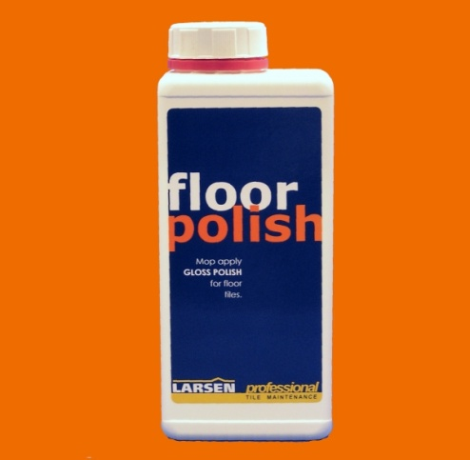
- Floor polishes form a protective barrier to prolong the life of the floor
- Furniture that is made of laminate or has a lacquered surface does not need polish applied. An all purpose cleaner will be sufficient
- Unsealed wood should have a wax polish applied periodically to "feed" the wood e.g. unsealed parquet flooring often used for dance floors
- Many of the spray can polishes are water based containing a small amount of solvent and silicones and can be used on most modern wood surfaces to remove dust and light soil
- There are many different floor seals and polishes and the selection should be based on the type of flooring product that you have to clean. Floor polishes are applied usually with a mop and bucket in the first instance and then maintained by buffing.

Solvents
Solvents are contained within many detergents in small quantities for general cleaning. Used individually, solvents are one of the most dangerous categories of chemicals that may be used for specific cleaning purposes.
Solvents include:
- White spirit-used for dry cleaning
- Mineral Turpentine - used for removal of oil based paint
- Perchlorethylene - used as a dry cleaning fluid
- Methylated spirits - used as a quick drying agent in window cleaners
- Acetone. This is used in nail polish remover and may be necessary to use when nail polish has been spilt as in guest rooms.
The use of solvents in every day cleaning should be limited. Always ventilate an area well if used and handle with great care.

General Precautions when handling chemicals
- Always read all instructions in relation to the safety features of each chemical and their usage
- Always read the instructions for each chemical so you know what first aid is required in the case of accidents
- Wear the correct protective clothing necessary for the tasks you are performing
- NEVER mix any chemicals
- Use correct handling procedures
- Store correctly as recommended in a secure area
- Report any chemical accidents or spillages. If there is a spill kit provided, know how to use it
- Know what to do should there be an emergency situation with chemicals
- Clean up minor spillages immediately and know the procedure should there be a very large spill
- Always have the correct chemical in the correct labelled bottle. NEVER use drink containers
- Toilet bowl cleaners should NEVER be used in a spray bottle as accidental spraying may occur. Use the special flip top cap on these bottles
- Always make sure that spray attachments are working correctly
- Always add chemicals to water, not water to chemicals as this is safer should there be any splash back
- Know where the nearest fire extinguisher is located in case there is a fire
- It is wise to have an eye bath near the chemical store in case of accidents
- NEVER smoke when handling or near to chemicals
- NEVER use chemical drums as seats or instead of ladders!

2.3 Select the protective clothing and equipment to be used

Introduction
There may be times when cleaning that you may need to wear protective clothing. This is for your own personal protection.
Most task descriptions will tell you when you need to wear protective clothing and what you should wear.
Always make sure that the clothing you are wearing is the correct size for you as if items are too big or too small, they will not serve the purpose for which they are intended e.g. Rubber boots that are too big may cause you to trip and fall.
TYPES OF PROTECTIVE CLOTHING | WHEN TO WEAR IT | COMMENTS
Uniform | - At all times | Your uniform will have been designed for the jobs you have to perform. | The uniform also represents the image of the company. Always wear it with pride and make sure it is clean and in good repair
Closed in shoes with slip resistant sole. | - At all times | Closed shoes will protect your feet should you accidentally drop something on your feet. | A slip resistant sole will also assist to prevent slipping on wet surfaces when cleaning
Gloves | - Handling chemicals  - Cleaning toilets and bathroom areas  - Heavy duty cleaning | There are many different styles of gloves for different cleaning purposes. They should be replaced regularly when damaged or for hygiene purposes | Always wear the correct size
Rubber boots | - Carpet cleaning  - High pressure washing | Apart from keeping the feet dry, they will act as a conductor of electricity if necessary when cleaning with large amounts of water. | Always wear the correct size
Goggles | - When decanting chemicals  - High pressure washing  - If cleaning in very dusty spaces | Ensure they are clean and well fitting
Face masks  (disposable style) | - When decanting chemicals | Ensure there is a good supply. | Will prevent inhalation of chemical fumes
Full face mask | - When using floor stripper chemicals or oven cleaners | Ensure the fit is correct and face mask shield in not scratched | To prevent splashes to eyes and skin that will burn.
Waterproof suit | - High pressure washing | Ensure they are well fitting
Jackets and Jumpers | - If cleaning outdoor areas when cold | To prevent chills
Sunglasses | - If cleaning outdoor areas when sunny or very hot | To prevent eye soreness
Hats | - If cleaning outdoor areas when sunny or very hot | To prevent sunburn
Thermal coat | - If cleaning inside cool rooms

2.4 Prepare the area

Introduction
Before starting to clean an area, you should prepare to clean. If this is done correctly, disruption to guests and other staff will be minimal and you will make your job easier.
Always have all your cleaning equipment, chemicals and accessories ready for the job you are about to do. If you do not have all that you need for cleaning, you will waste precious time by having to run back to the cleaners' store for something that you need or have forgotten.
Assess the area
- Sometimes before cleaning you may have to move furniture in order to do so e.g. if you are cleaning a restaurant or bar area where there is a lot of furniture , you may have to lift chairs or move tables
- If you need assistance to do this, call your supervisor. Never move items that are too heavy or need two or more people to do so as you may hurt yourself
- It may be necessary for you to close an area e.g. if you are mopping a toilet floor area during operational hours, you will need to close the toilets so that guests are not injured by slipping on wet floors or feel that their privacy is compromised
- If this is the case, always place the correct signage at the door with directions to other facilities
- In the case of cleaning a 24 hour restaurant, each section of the restaurant will need to be roped off at one time to facilitate cleaning
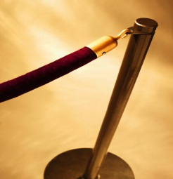
- This will be done in co-operation with the restaurant staff who will be able to close off sections after busy meal periods
- They will do this on a rotational basis with signage and ropes and stanchions.
This photo shows a rope and stanchion
- As a guideline never clean within three meters of where guests are sitting.
Periodic cleaning
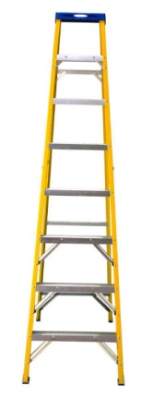
- If you are required to clean carpets or strip and seal floor areas, this will usually be done after hours or overnight
- Your supervisor will advise the relevant staff in advance of this specialised scheduled cleaning and time frames
- Help should be sought from other staff to remove all furniture in advance so that you will have more time to complete the cleaning tasks.
High cleaning
If you are required to clean high areas such as air vents or chandeliers, you may need to cover furniture and fittings or carpets and plants with drop sheets. This is to protect them from falling debris. Failure to do this will add time to the overall cleaning project and may also damage other surfaces if not protected. Do not forget to place caution signs and rope off the area if necessary.

2.5 Undertake the selected cleaning process

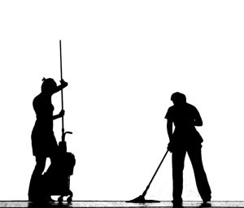
Introduction
Now you are ready to clean.

In what order should you work?
- Remove all rubbish and waste
- Cleaning is then divided into dry or wet tasks
- It is usual that where there are dry tasks these are completed first followed by wet tasks
- High cleaning is done before low cleaning (dust falls down)
- Floor cleaning is done last (to clean all the debris from the cleaning process)
- Work systematically around a room or area so you do not miss any surface or forget to clean an item
- Work clockwise if possible completing one task at a time and work backwards towards the exit door.
CLEANING METHOD | USES | WET | DRY
Remove waste |  | Remove waste
Blowing | Outdoor collection of leaves and litter |  | Yes
Blasting  (High Pressure ) | Heavy soil on footpaths, walls and building exteriors | Yes
Brushing-manual | Cleaning walls of cobwebs |  | Yes
Buffing-machine | Polished floors |  | Yes
Burnishing | Polished floors |  | Yes
Dry Foam & upholstery cleaning | Carpets & furniture | Yes
Dusting | Furniture and fittings  Picture frames and decorative items |  | Yes
Dust mopping | Hard floors |  | Yes
Hot water extraction | Carpets & upholstery | Yes
Mopping | Hard floors | Yes
Polishing Machine | Polished floors |  | Yes
Polishing - Manual | Furniture, metal cleaning |  | Yes
Scrubbing - Machine | Hard floor and surfaces | Yes
Scrubbing - Manual | Hard floors and surfaces  Cleaning toilets | Yes
Spot clean - Manual | Carpets , furniture fabrics  Windows and mirrors | Yes
Spot clean -Machine | Carpets , furniture fabrics | Yes
Stripping - Machine | Polished floors | Yes
Sealing | Polished floors | Yes
Steam cleaning | Bathroom surfaces and all kitchen areas | Yes
Sweeping - Machine | Hard floors |  | Yes
Sweeping - Manual | Hard floors |  | Yes
Vacuuming - Dry | Carpets and hard floors, air vents and upholstery |  | Yes
Vacuuming - Wet | Hard floors, carpets | Yes
Washing | Walls, doors , paintwork  Floors (hosing)  Bathroom surfaces  Windows | Yes

2.6 Dispose of waste

Introduction
Disposal of waste should be done regularly throughout the day in order to remove the possibility of bad smells and to eliminate the possibility of attracting pests and vermin.

Types of waste
- Food waste
- Dry waste
- Waste that can be recycled
- Medical and infectious waste
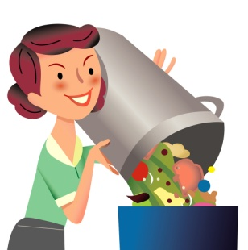
- Return waste.
Food waste
This is generated primarily from restaurants and kitchen areas although there may be some from staff lunch rooms. This should be disposed of in heavy duty garbage bags tied at the top. The bags should not be overfilled or leak.
Dry waste
The amount of dry waste produced by hotels has been dramatically reduced due to the increase and availability of recycling. There is still dry waste produced such as used paper towels and cigarette butts and food wrappings. This is classified as general rubbish and should be disposed of in garbage bags.
Where you are removing cigarette butts from ashtrays, always ensure that they are not smouldering.
Waste that can be recycled
Currently much of today's waste may be recycled by companies and local government bodies. Due to the increased information and awareness of environmental issues, most businesses recycle some of their waste. Find out the procedures at your workplace, if any, for recycling.
Recyclable waste may include:

- Newspapers and magazines
- Cardboard boxes
- Bottles and cans
- Metal items (old fridges and washing machines)
- Toner cartridges.

Medical and infectious waste
- Waste that is potentially infectious may include surgical and sanitary dressings, used condoms and syringes. Sanitary dressings are usually disposed of in special sanitary units located in female toilet areas. The designated contractor will be responsible for correct disposal of this waste
- Used condoms should be handled by wearing rubber gloves and wrapping in paper before disposing of in the dry waste
- In hotels, there may be times when syringes are discovered in public toilets or in plant pots. These must be disposed of correctly in a sharps container. Some public toilets have installed wall mounted units but many users do not dispose of syringes thoughtfully
- Find out the correct procedure in your work area for disposal of these items. When full these containers are sent to a medical waste company for correct disposal. They are usually burnt.
Return waste
This applies to waste that is returnable to its source. Some companies for example refund monies for the return of empty containers e.g. bottles, chemical containers, and milk crates.

Disposal of waste
Waste storage
- All waste is usually taken to a central area where it is stored until it is collected by outside contractors
- This area must be located far away from the public areas in a separate designated area
- The area may have many separate bins with lids or there may be one or more large bulk storage bins
- The storage area should be kept as cool as possible to avoid rubbish rotting and smelling until it can be collected
- In large properties this may be daily or several times per week depending on volume
- The rubbish storage area should have access to hot water for cleaning and preferably have an easy to clean floor. Many food establishments have a steel non slip floor for hygiene reasons.
Rubbish chutes
High rise buildings may have a rubbish chute accessible from each floor where all waste can be disposed of to a central area. With this process, rubbish may fall directly into either a bulk rubbish bin or into a rubbish compactor.
It is NOT recommended that glass bottles be placed down a rubbish chute. Because of the speed at which they fall, they can shatter on impact and cause injury to people below. Large cardboard boxes can also block the chute if not broken into small pieces.
The doors on each floor must be locked at all times for safety reasons.
Rubbish compactors
When rubbish is placed into a rubbish compactor, the machine compacts the rubbish into a large storage (compaction) unit. The units grinds and presses the rubbish and when the compaction unit is full, it is transported off site and replaced with another one by a waste disposal contractor.
The compactor unit needs to manned to ensure there are no blockages.
Rubbish may also be placed manually into the compactor unit where there is no chute. Some units have a lifting device attached which can lift and empty rubbish bins directly into the unit.
Manual rubbish compactors
There are many styles available but manual compactors are useful when rubbish storage areas are small. They can be used for general dry or wet rubbish or for paper and cardboard. The latter have a baling action which can tie up piles into bales ready for collection for recycling.

Precautions when handling waste
- ALWAYS wear rubber gloves when handling rubbish. When picking up cigarette butts, empty drink containers or used tissues, you will be also picking up other peoples' germs. You should pick these up with long handled tongs or "nippers "
- NEVER place hands in to any type of rubbish bin as there may be broken glass or razor blades on which you can cut yourself
- ALWAYS cover any cuts or abrasions on your hand with a waterproof dressing to prevent bacteria entering the wound
- NEVER carry rubbish bags that are too heavy - use a trolley
- NEVER dispose of broken glass or syringes into plastic bags. They may pierce the bag and cause harm to you and others
- Broken glass and crockery should be wrapped in thick newspaper before disposal. Some workplaces may have a special bucket for holding broken glass and crockery
- ALWAYS wash your hands after handling rubbish.

2.7 Return area to operational condition

Introduction
Once cleaning of an area is complete, it is important it is returned to an operational condition. This means that the area should be ready for use and be sparkling clean. Once you have finished cleaning, it is important to do a final check of the area for any spots, marks or stains that you may have missed. Check that you have not left any cleaning rags or equipment behind.

Always remember to:
- Remove ropes and stanchions back to the correct storage area
- Remove cleaning signage
- Remove all cleaning equipment from the area
- Remove any drop sheets used
- Reposition any furniture that was moved when preparing the area
- Turn off any cleaning lights and reset mood lighting if appropriate
- Always lock all necessary doors
- Reset the alarm or advise security staff
- Advise your supervisor when you have finished cleaning if this is a requirement. The supervisor may want to check your cleaning standard
- Remove rubbish to the disposal area
- Remove your cleaning equipment to the store and replenish as required.

2.8 Clean, check and store cleaning equipment and chemicals

Introduction

At the end of your working shift, you will need to clean and replenish your cleaning chemicals and equipment. If you do this, you will save time for your next shift and keep your working area clean and well-maintained.

Cleaning equipment
Vacuum cleaner
The vacuum cleaner should be checked daily after each use.
- Empty or replace the dust collection bag as necessary
- Check that the vacuum cleaner is working correctly
- Clean the floor attachments if necessary and remove any threads or fluff and wipe down the exterior of the machine
- Check the extension pieces are not blocked. Unblock if necessary
- Check the electrical cord that it is not frayed or split
- Check the plug and on/off switch
- Check the wheels are rolling correctly. Sometimes carpet fluff may accumulate and stop them from rolling smoothly
- If the wheels are squeaking you may need to oil them
- Wind up the cord and store correctly and neatly
- Replace other filters as per the manufacturer's instructions.
Wet cleaning machines
- Always drain recovery tanks and flush through with clean water
- Always drain the cleaning solution tanks. Never leave a chemical solution in a machine as it will deteriorate and could also rust any fittings. Dirty water may smell if left to stand
- Wash and dry all attachments and hang up to dry
- Brushes and cleaning pads should be rinsed and hung to dry
- Damp wipe the exterior of the machine
- Always store scrubbing and polishing machines without the base plate and leave the wheels down
- Check all cords and plugs as you wind them up.
Report any faults with electrical machines immediately and remove from service.
Cleaners' trolley
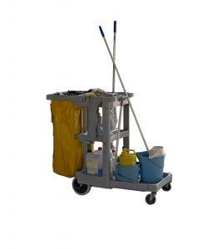
- Remove all waste in accordance with your property's guidelines
- Clean all debris from your trolley and wipe down empty shelves
- Place soiled cleaning cloths in the correct receptacle. Some may need to be thrown away and others placed for laundering
- Replenish all stock as needed (toilet rolls, soap and paper towels, garbage bags)
- Ensure the trolley is stacked neatly.
If there is more than one trolley, it is preferable to stack them all in the same way so that items are easily accessible and time is not wasted by "negotiating the trolley".
General cleaning equipment
- Clean all dustpans and knock all brushes to remove loose debris
- Store brooms with bristles upwards
- Wash toilet brushes in hot water and detergent solution and then repeat with disinfectant. Keep separate from all other cleaning equipment and leave to dry. Replace when bristles start to drop or become flat
- Wash and rinse all mops and squeeze as dry as possible. If you have removable and washable mop heads, these may need to be placed aside for laundering
- Other styles of mop heads will need to be washed in hot detergent solution and rinsed until the water is clear. Squeeze out as much as possible and hang them to dry (mop head downwards)
- Replace mop heads as soon as they start to drop the strings
- Empty all buckets into an approved sluice sink or drain. Wash and rinse the buckets and remove any debris
- Place upside down on a shelf to dry. This will stop a metal bucket from rusting quickly
- Check the wheels, wringers and rollers on all buckets are in working order
- Clean the sluice sink
- Sweep and mop the cleaners' store floor.
Protective Clothing and Equipment
Always check any protective clothing and equipment you may have used.
- Dispose of damaged rubber gloves and replace them
- Arrange for soiled clothing to be laundered as per your property's procedures
- Check all other pieces and replace as necessary.

Chemicals
Part of your responsibilities after cleaning is to refill all the necessary chemical bottles.
- Wear gloves and goggles when handling the chemicals
- Always refill from the correct dispensers and wipe the bottles
- Check that the sprays are working and if they are not, replace the spray trigger tops
- Always make sure that the labels have not peeled off and are still legible
- Wipe up any spills and store correctly
- Should the chemical dispensers need refilling, learn how to do this and know the procedure for requisitioning additional cleaning supplies.

Finally
Always make sure that the cleaning store is neat and tidy and everything is stored in its' correct place. Like items should be stored together. Lock the door.

Work Projects
It is a requirement of this Unit that you complete Work Projects as advised by your Trainer. You must submit documentation, suitable evidence or other relevant proof of completion of the project to your Trainer by the agreed date.
1. Write the procedures that relate to all aspects of security in your workplace when cleaning.
2. Demonstrate to your trainer the use of:
- A vacuum cleaner
- A rotary machine (any style).
3. Demonstrate to your trainer the complete cleaning of either an office or a toilet block.
4. Provide a check list for the care of all general cleaning equipment.

Summary

Clean industrial work areas
Assess area to be cleaned
Know the scope of cleaning
Know when to clean
Understand your role in securing the property.
Report unusual activities
Recognise different types of soil
Know the different cleaning methods.
Select appropriate equipment and chemicals
Locate different types of electrical cleaning equipment and know their uses
Locate general cleaning equipment.
Select the protective clothing and equipment to be used
- Know which clothing and equipment to wear when performing different cleaning tasks.
Prepare the area
Assess the area
Identify any dangers
Place any signage and barriers.
Understand the cleaning process
- Know which order to work in.
Dispose of waste
Handle different types of waste
Know correct disposal procedures
Understand mechanical disposal machines
Take precautions when handling waste.
Clean, check and store cleaning equipment and chemicals
- Clean all electrical equipment
- Report any faults
- Check and clean all protective equipment
- Stack and clean trolley
- Check and refill chemicals.

Element 3:
Clean industrial work equipment

3.1 Assess suitability of equipment for cleaning

Introduction
From time to time, there will be items in a work environment that will require specialised cleaning. These may include:
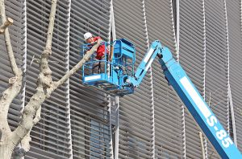
High level cleaning
- Decorative items like wall hangings or tapestries
- Chandeliers and decorative light fittings
- Ceiling fans and decorative ceilings (lights and glass)
- Outdoor signage
- Window and roof cleaning
- Car park high level pipes.
Low level cleaning
- Escalators
- Display cabinets
- Hard floors
- Fountains
- Commercial kitchen equipment
- Industrial laundry areas.
Cleaning in place equipment (CIP)
- This is a method when equipment used for food processing is cleaned in place without the need for disassembling. It is cleaned by a series of pumps to draw cleaning and rinsing solutions through pipes and equipment. It is not widely used in hotels.
Considerations
When planning to clean certain items, always consider:
- When can I clean?
- What special equipment will I need?
- What protective equipment will I need?
- What are the potential hazards?
- Will I need any special cleaning chemicals?
- Which pieces of cleaning equipment will I need?
- How many staff will be needed to complete the work in the time frame available?
- Does maintenance staff need to be involved?
- Who needs to know? e.g. if you are cleaning hotel signage in the hotel driveway, then porters will need to be aware so that they can plan ahead for car parking and maintenance staff may need to repair items at the same time you are cleaning like light globes.

High level cleaning
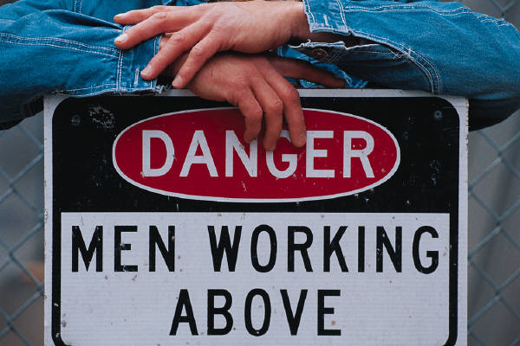
High level cleaning will take place periodically and should be planned so that it does not cause inconvenience.
- Always communicate to all parties when and how the cleaning will take place
- Select any safety equipment that will be required. You may need to rent certain equipment on a short term basis such as mobile scaffoldings
- Follow all safety procedures. Use a harness if appropriate
- Select protective clothing (hard hats, face masks, high visibility vests)
- Erect signage and place barriers below the cleaning
- Remove, if possible, or cover any furniture or fittings below to protect them from debris
- Switch off any power if applicable (signage, lights and ceiling fans)
- Complete the cleaning tasks
- Remove all barriers, covers and signage.

Low level cleaning
Sometimes even low level special cleaning tasks can inconvenience hotel guests and staff. Where there are items like escalators and fountains, the cleaning of these items needs to be done after hours or during quiet periods.
Cleaning a fountain
Many hotels have a fountain in the entrance grounds or lobby as a decorative feature.
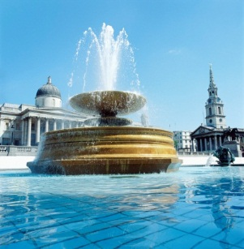
- Advise all relevant personnel of the planned cleaning time
- Liaise with maintenance staff to turn off water pumps and electrical equipment
- Erect signage and barriers
- Remove if possible or cover any fittings and fixtures close to the fountain
- Switch off the water pump and any lighting inside the fountain. (Maintenance staff will clean pumps)
- Isolate the power source
- Completely drain the fountain
- Remove any large debris wearing gloves (plants, coins, bottles)
- Using a wet pick up vacuum, suck up the remaining water, dirt and debris
- Clean all decorative fittings - pebbles, tiles, light fittings, ornamental items removing any algae and dry them
- Clean the drains and filters
- Remove all signage and barriers.

3.2 Select appropriate cleaning equipment and chemicals

Introduction
Now that you have previously learnt about equipment and chemicals, you should know which chemicals in your workplace are to be used on all the different surfaces. If you are unsure, always refer to the task description, the technical bulletin or your supervisor.

Select appropriate chemicals
Whilst there are many cleaning chemicals available for general cleaning tasks, there may be times when you need to select a single purpose chemical e.g. metal cleaning, oven cleaning, descaler for kettles, irons and urns, floor sealers. Always ensure you have these on hand when necessary to perform these tasks.



Select appropriate cleaning equipment
Always review special tasks so that you will have enough equipment on hand.
Chemical summary | Main uses | Warning | Comments
Abrasives | Clean by scratching | Use sparingly | Do not use on painted walls, glass and furniture
Acids | Used on toilets  Metal cleaners can be slightly acidic | Can burn eyes and skin  Use correct bottle with pour cap | Wear gloves and so not use near marble floors
Alkalis | Used as degreasers and oven cleaners,  Floor cleaners are slightly alkaline | Can burn eyes and skin | Wear protective clothing
Disinfectants | Use to kill bacteria | Not a good cleaner | Replace solution when dirty
Detergents | Washing, carpet cleaners, window cleaners | Use at correct dilution rates | Are fairly neutral and easy to use
Polishes | Floors and furniture | Apply as per manufacturer's instructions
Solvents | Dissolving other products  Used in window cleaners, paint thinners, nail polish remover | Very dangerous | Use rarely
Single purpose chemicals | Leather, metal, oven cleaners | Use as directed

3.3 Select the protective clothing and equipment to be used

Introduction
Always wear and use the correct protective clothing and safety equipment for the job you are doing. Use it in the correct way and never play with it or damage it. Always store it in the correct place so that it is readily available. Do not take short cuts with protective clothing as this could lead to accidents and injury either to you or other people. Always make sure that the clothing is the correct fit for you.
Clothing | Usage | Equipment | Usage
Gloves | Different types for different tasks | Tongs | For picking up syringes
Aprons | Rubber for wet work, plastic for food handling, fabric for general protection | Nippers | For pick up of cigarette butts and litter
Goggles | Eye protection - wear when handling chemicals | Ladders | Always use the correct height for the task
Full face masks | Cleaning oven and grills or pressure cleaning (blasting) | Harness | To be used when working at heights
Shoes | Closed in to protect feet and should have slip resistant sole | Respirator | Use where there are fumes or high dust levels
Rubber boots | For hosing, pressure washing and when using a carpet cleaning machine
Uniform | General protection and identification to guests
Hard hat | Use when there is a possibility of items being dropped
High visibility vests | To be seen easily

3.4 Prepare equipment for cleaning

Introduction
How do you prepare equipment for cleaning?
- Identify the piece of equipment that is to be cleaned
- Identify potential hazards and switch off any power if necessary
- Unplug if possible
- Turn off gas is necessary
- Turn off water supply if appropriate
- Let the equipment cool down if needed
- Remove if possible any fixtures and fittings if possible from the immediate area
- Cover any fixture and fittings in close proximity with dust sheets
- Erect signage
- Erect barriers
- Identify any work restrictions that may apply to a particular task.

3.5 Clean equipment as identified

Introduction
We have identified cleaning chemicals and equipment that is available to be used. This section covers the use of those items in differing cleaning methods.

Cleaning hard floors
Sweeping
There are several different ways in which to sweep a floor. Sweeping can be done with a broom, a dust mop or a manual sweeper. Sweeping is usually completed before either wet cleaning or maintaining a polished floor. The choice of which you should use will depend on:
- The size of the area
- The type of flooring and its finish
- The type of soil.
For example, large areas of concrete such as multi-storey car parks would take forever to clean if you were just to use a broom or dust mop. Similarly a small area of wood flooring or stairway would not be cleaned using a manual sweeper as the brush would be too harsh for the surface and the machine too large to use.

- Before sweeping, clear the area of obstacles including furniture or mats
- Start in one corner and push the broom, dust mop or sweeper away from you
- Walk in a straight line towards the far end of the room or area
- Turn around without lifting the broom or dust mop off the floor overlapping each stroke
- Continue in this way until you have covered the whole area
- Once you have finished, pick up all the dust and litter you have collected and dispose of waste
- Only used a dry dust mop
- Empty the hopper on the sweeping machine and dispose of waste.
Mopping
Wet mopping will remove any surface dirt and stains.
- Half fill a mop bucket with hand hot water and add the correct amount of the selected detergent
- Select the correct mop
- Erect correct signage at both ends of the area you are about to mop
- Wheel the bucket to the area and position it where it will not be knocked over or present as a hazard to others
- Start at the furthest point away from the exit door so you do not walk over the wet floor
- Wet and squeeze out the mop using the wringer attachment
- You must then open up the mop by twisting the handle
- Using a figure eight pattern, mop the floor as you walk backwards
- If the area is very big, you may have to start again at the end of the room and continue in the figure eight method, overlapping slightly so the floor is not left streaky
- You will need to keep rinsing and squeezing your mop so that you do not re-deposit dirt on the floor
- Scrape up any chewing gum and if stains remain, you may need to use a scouring pad to loosen them. A white scourer is preferable as this will not scratch
- Avoid over-wetting the floor so that drying time is minimal and that you do not splash walls and doors. This is particularly important if the area is subject to heavy foot traffic
- If you are wet mopping a corridor or stairway, you may have to mop half the area at a time to allow for foot traffic. Wait until the one half is dry before mopping the second half
- Pay particular attention to the corners where the mop may not reach
- Keep your back straight. It is not necessary to bend.

Machine scrubbing a hard floor
Using either a rotary or automatic machine, hard floors can be wet scrubbed.
a) Rotary machine
- Erect signage
- First sweep the floor and collect the waste
- Apply the mopping solution quite liberally
- Use the rotary machine with the brush attachment, scrub the floor by passing the machine over the cleaning solution already on the floor. There will be different types of floor brushes used depending on the floor surface material being cleaned
- The final step will be to either a) rinse the floor with clean water only or b) use a wet pick up vacuum
- These machines are ideal for smaller areas like toilet blocks or kitchen areas.

N.B. - Always ensure that the electrical cord is behind you. Do not allow the brush to rotate over the cord.
b) Automatic scrubbing machine
Automatic scrubbing machines are much more efficient in cleaning large areas.
- Erect signage
- Fill the solution tank with hot water and chemical solution
- The dispensing of cleaning solution, scrubbing action and suction of the dirty water is controlled by operating the switches close to the drive handles
- The operator pushes or drives the machine in a forward straight line and then turns around walking continuously overlapping slightly. The machine should leave the floor almost totally dry
- Always empty both solution tanks when cleaning is complete.
Stripping polish from hard floors
Depending on the amount of foot traffic, stripping polish off floors should only be done when the existing polish breaks down and the floor looks dull. In most cases, this should be done between two or four times per year. Stripping is the preparation process before resealing and applying polish. Stripping can be done either manually, by machine or a combination of both. The type of stripper used will be determined by the type of polish that has been used previously and the type of flooring material.
- Erect signage
- Sweep the floor and remove all debris
- Remove any furniture and fittings
- Wear protective clothing including rubber boots, heavy duty rubber gloves and goggles as the floor stripper is extremely alkaline and therefore corrosive.

Select the mop and bucket. The bucket that holds stripping solution and the mop used for stripping should be used ONLY for this purpose.
- Place stripping solution into the bucket. Read the instructions for use
- Apply stripper to the floor using the mop and spread liberally across the floor working from side to side. Do not apply the stripper around all the edges (approximately 5 cm wide). Avoid splashing walls and skirting boards as the chemical may remove the paint
- Leave for at least ten minutes or as recommended by the manufacturer
- With the solution still on the floor, scrub the floor using a stripping pad. Use either a black or brown scourer on a long handled attachment (called a doodlebug) or use the rotary machine with the black scrubbing pad
- The hand held scrubbing attachment is better for scrubbing around the edges
- The next step is to pick up the scrubbing/stripping by either using a wet pick up vacuum or by mopping. Do not allow the floor to dry between stripping and rinsing
- Mopping should be done using CLEAN water and a CLEAN mop to thoroughly rinse the floor. You may have to repeat this process several times
- As you rinse, wipe any splashes off walls and doors
- When the floor is dry, ensure that all the polish has been removed. If not, repeat the process
- Remove any black marks from the floor by using steel wool gently
- When the floor is dry, the floor is then ready for the application of polish
- Clean all cleaning equipment.
Sealing and polishing of hard floors
The type of sealer or polish will be determined by the type of flooring material used. Polish may be applied by using a special polish applicator or mop.
- Erect signage.
The bucket and mop used for applying polish should only be used for this purpose.
- Place the polish in the bucket and place the mop in to the polish
- Wring out the mop gently
- Apply the polish on to the floor in a sweeping left to right motion, applying lightly at the edges
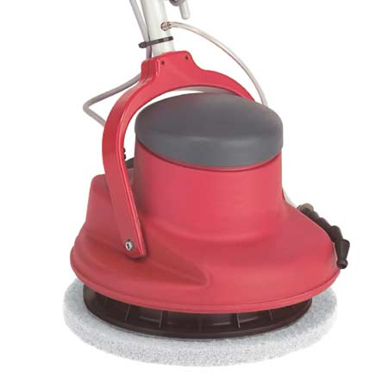
- Allow the polish to dry completely as per the manufacturer's instruction
- Once dry, apply another two coats. The second and third coats should not have the polish applied to the edges
- Once all coats are dried, use the polishing machine with the polishing pad. The high speed of the machine helps to harden the polish
- You may have to apply another two or three coats over a few days.
Buffing hard floors
The buffing of hard floors is the maintenance of the floor you have previously stripped and sealed. Daily mopping will keep the floor clean but when the floor starts to dull, then spray buffing will bring back the shine to traffic areas. It is recommended to spray buff at least weekly.
- Erect signage
- Sweep or dust mop the area to be clean and remove the debris
- Arrange the polishing machine with the correct pad for buffing
- Spray the floor finish (as per manufacturer's instructions) lightly over a small area at a time. (Do not overuse)
- Whilst the floor is damp, use the buffing machine and pass over the floor. The rotation of the machine will dry and polish at the same time.
Blasting or Pressure cleaning
This includes using water, sand, soda or dry ice.
Sand is used rarely now as the dust produced in long term use has been proven to cause silicosis, a fatal lung disease. It was used for cleaning the exteriors of buildings.
Soda blasting is used for stripping paint and graffiti off masonry and removing soot from smoke damaged surfaces.
Ice blasting uses ice pellets for cleaning food manufacturing equipment.
Water is the main element for cleaning in this process.
Pressure washing is a useful method of cleaning for heavy soil build up on footpaths, walls and building exteriors. It may be useful in the removal of some graffiti. As this method produces excessive water runoff and spray, then it is imperative to use only where the water and debris can be successfully drained away. It is a method that is best for exterior use. If used internally, extreme care should be taken to ensure the water does not cause damage to other areas or surfaces. It may be useful to use a wet pick up vacuum to collect the excess water.
- Erect signage and close off the area to be cleaned with barriers
- Wear protective clothing - waterproof overalls, goggles, rubber boots and gloves
- Start by cleaning high areas first, then working downwards
- Flush all debris away
- Remove signage and barriers when the area has been tidied.

Cleaning of soft floors
Vacuuming
Vacuuming is one of the most common cleaning methods. Vacuum cleaners are used primarily for cleaning carpets and rugs but can be used to vacuum hard floors, air vents, curtains and upholstery using a variety of attachments.
- Erect signage if necessary
- Remove any hazards and furniture as required
- Select the largest vacuum cleaner possible for the area to be cleaned
- Manually pick up any large pieces of litter as these may block the vacuum cleaner
- Start at the furthest point and vacuum towards the exit door
- Pay particular attention to the edges and corners of carpets, under tables and chairs and behind open doors
- If you see a hole, tear or broken seam or an area of threadbare carpet, make a note and report this to your supervisor
- Any stains or spots should be attended to as soon as possible. If you have not been trained in carpet spotting, do not attempt to clean the spot.
Tool attachments
- Power head. This has a separate motor which drives a rotating brush which helps to lift flattened carpet pile and remove in-ground dust and dirt particles at the base of the pile
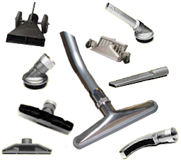
- Carpet tool. This is a flat tool which glides over the carpet
- Brush head. This is an attachment for hard floors
- 2 in 1 head. This is a combination tool which can be converted simply from cleaning carpet to cleaning hard floor simply by pushing lightly with the foot
- Crevice tool. This is flat tool which is used for vacuuming in confined areas and around the edges
- Upholstery brush. This can be used on upholstery or for vacuuming cobwebs from high walls.

Blockages
- From time to time when vacuuming, suction may be reduced through blockages either in the hose, tubes or in the nozzles
- Blockages happen because something has been picked up by the vacuum cleaner which is too big. These are items like matchsticks, toothpicks, bottle tops
- The item lodges in the hose sideways and then all other fluff and debris builds up behind it
- There are several ways to unblock the item
- Pull apart the tubes from the hose and nozzle. Check each piece for the blockage. If the tubes are blocked, this can be removed by simply pushing a broom handle through the tube to release the items
- If the blockage is in the nozzle it should be easily visible and be easily removed
- If the blockage is in the hose and you cannot reach it with the broom handle, flush water through the hose over a sink. This should remove the blockage BUT you will need to hang the hose up for several days to dry out. If you do not do this, dust will stick to the inside of the hose and will block again
- With an upright vacuum cleaner the blockage is usually under the brush at the base.
Bonnet cleaning
Bonnet cleaning of carpets is a quick method of carpet cleaning but its disadvantages are that it leaves a residual smell and the result is short term. Whilst the method is relatively easy, it does not produce a deep clean but it can remove most surface soil and is quick drying.
- Ventilate the area to be cleaned well
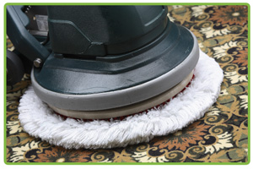
- Erect signage
- Select appropriate protective clothing - respirator, gloves and rubber boots
- Pre-spray the carpet with cleaning solution if heavily soiled
- Dip the bonnet pad in to the cleaning solution and lightly squeeze
- Attach the "bonnet" to the pad holder of the rotary floor machine
- Pass the machine at low speed over the carpet similar to the method described for the rotary shampoo machine.
- Change the pad regularly as it will absorb dirt from the carpet
- Once cleaning is finished use a clean dry pad on the machine to dry the carpet
- Vacuum the carpet
- Remove signage and tidy the area.

Hot water extraction
This method of carpet cleaning is designed to deep clean the carpet.
- Erect signage and barriers
- Wear rubber boots
- Fill the solution tank with water and add the selected detergent at the correct dilution rate
- Attach the hose and carpet cleaning tools to the machine
- Switch on both motors
- Plan the cleaning so that you do not walk on the wet carpet
- Pre-spot any obvious stains
- Press the injection trigger to release the solution on to the carpet and pass the wand several times over one small area
- When clean, use the suction and pick up the cleaning solution
- Move to the next section
- Overlap each pass so that no section of carpet is missed. Failure to do this will result in a streaky finish caused by having stripes of dirty carpet
- Work back towards the exit door
- Ventilate the area and leave the carpet to dry naturally
- Leave signage until the carpet is dry.
Spot cleaning of carpet
There are many stains which can spoil the look of a carpet. The most common stains in hotels are food stains, alcohol, coffee, tea, shoe polish and grease. The sooner a stain is treated the more chance there is of total removal.
- Scrape up any solids and dispose of accordingly. (Chewing gum can be hardened by placing ice on it. The ice will freeze the gum which can then be scraped off)
- N.B. Chewing gum can be found on both hard and soft floors but is also found on the underside of tables in bars and restaurants
- Pour water on the stain (this will dilute whatever the stain is). Then blot gently with a clean cloth. If the stain is large, place a weight on top of the cloth. This will help the cloth to soak up the stain
- DO NOT RUB OR SCRUB as this will spread the stain
- Try to identify the stain by asking staff, the appearance or smell of the stain or by feel
- Using spotting chemicals provided by your chemical supplier and charts, apply the selected stain remover and use in conjunction with the manufacturer's instructions
- Always use the most gentle stain remover first before using solvents
- Work from the outside of the stain towards the middle, gently massaging the fibres of the carpet
- Flush through with water
- If stain removal chemicals do not work, you may have to use the hot water extraction unit or call in professional carpet cleaners
- If nothing will remove a stain, you may have to arrange to replace a section of carpet.
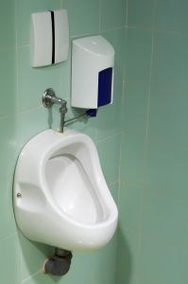
Clean wet areas
Wet areas include swimming pools, saunas, laundries, toilets, bars (servery) and bathrooms.
- Erect signage
- Select the correct chemicals and equipment for the surfaces to be cleaned
- Remove all waste from the area
- Wash the bins and replace liners
- Lift up any furniture and fittings off the floor if possible
- Work in a methodical way completing one task at a time
- Dust or damp wipe all dry surfaces cleaning from top to bottom (picture frames, furniture, door fittings, fire extinguishers, plant pots, skirting boards etc. working in a circular way around the room
- Clean all wet surfaces - toilets, urinals, basins, sinks, baths, showers as per the task description
- Spot clean mirrors and glass surfaces
- Replace all consumables - toilet paper, towels, soaps
- Sweep and mop the hard floors working towards the exit door. Do not forget to clean behind the doors
- Spray air freshener
- Return later when the floor is dry and check all surfaces for spots and stains
- Re-clean as necessary and remove signage.
Clean dry areas
Dry areas are offices, restaurants, lobby areas and functions rooms.
- Erect signage
- Select the correct chemicals and equipment for the surfaces to be cleaned
- Remove all waste from the area
- Wash the bins and replace liners
- Dust or damp wipe all dry surfaces cleaning from top to bottom (picture frames, furniture, desks, chairs, filing cabinets, door fittings, fire extinguishers, plant pots, skirting boards etc. working in a circular way around the room
- Lift up any furniture and fittings off the floor if possible
- Sweep and mop any hard floors
- Vacuum the carpet working towards the exit door
- Re-position all furniture
- Remove signage
- Check all surfaces for spots and stains
- Re-clean as necessary and remove signage.

3.6 Tidy work site

Introduction
All professional cleaners will always leave the area they have cleaned in pristine condition.
- Remove all work equipment
- Replace all furniture, fittings and fixtures back in to positions and clean if necessary
- Remove all barriers and signage
- Remove any covers
- Remove all cleaning equipment and accessories
- Restore power and utilities if necessary
- Check all equipment is in working order after the cleaning process.

3.7 Dispose of waste

Introduction
Apart from the disposal of waste already covered in element 2.6 you may need to also dispose of certain chemical waste which is a by-product of the cleaning process.

Removal of chemical waste
- Always read the material safety data sheet (MSDS). This should have directions for correct disposal of chemical waste
- Follow these instructions exactly
- Some chemicals should not be flushed down the drain as they could be corrosive or impact on the environment
- Use a registered accredited commercial chemical waste disposal company.
Items that should be professionally disposed of:
- Acids
- Alkalis
- Aerosols
- Waxes
- Paint cans
- Paint thinners
- Solvents
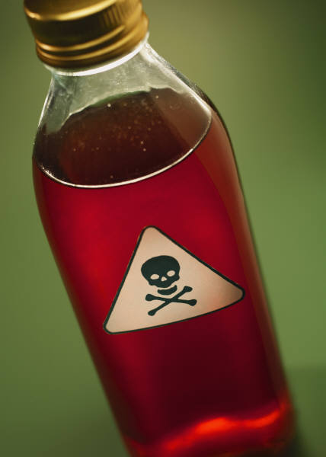
- Oven cleaners
- Pest poisons
- Glues
- Fertilisers.
What to do in case of a chemical spill
- Only trained staff should deal with a large chemical spill
- The size of a spill will affect how you deal with it
- Attend to staff who may have been affected and let them decontaminate under a shower for 10-15 minutes
- Remove and dispose of all contaminated clothing
- If the spill is large, all staff should be evacuated from the immediate area
- Ventilate the area as much as possible
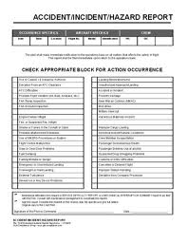
- Call the relevant emergency services to assist and advise
- Wear protective equipment at all times in this situation -gloves, face mask, protective clothing and rubber boots
- Try to stop the spill if possible. Turn off the tap or place the container on its side. The use of sand or an absorbent compound (sand or sawdust) is particularly helpful in this case. This can then be swept up as solid matter and disposed of later
- Wash the area down completely after clean up
- Investigate how the spill occurred in order to review all handling procedures
- Record the incident and retrain staff.

3.8 Clean, check and store cleaning equipment and chemicals

Introduction
At the end of your working shift, you will need to clean and replenish your cleaning chemicals and equipment. If you do this, you will save time for your next shift and keep your working area clean and well maintained.
Report any faults with electrical machines immediately and remove from service.

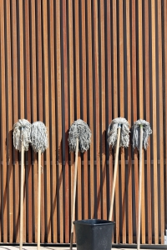
Cleaning equipment
Always clean your:
- Vacuum cleaner
- Wet cleaning machines
- Cleaners' trolley
- General cleaning equipment
- Protective clothing and equipment.

Replenish Chemicals
- Part of your responsibilities after cleaning is to refill all the necessary chemical bottles
- Should the chemical dispensers need refilling, learn how to do this and know the procedure for requisitioning additional cleaning supplies.

Remove waste and finally
- Always make sure that the cleaning store is neat and tidy and everything is stored in its correct place. Like items should be stored together
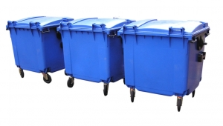
- Sweep and mop the floor
- Lock the door.

Work Projects
It is a requirement of this Unit that you complete Work Projects as advised by your Trainer. You must submit documentation, suitable evidence or other relevant proof of completion of the project to your Trainer by the agreed date.
1. Research the equipment that is available for cleaning escalators. Compare the differences between manual cleaning and mechanical methods. If you were the General Manager, which method would you recommend and explain your reasons. Make a presentation and include photographs or a video.
2. Select a piece of work equipment for cleaning and:
- Plan to clean this item
- Demonstrate to your trainer the cleaning task in full including disposing of waste, tidying the site and cleaning and checking of all equipment and the replenishing of all chemicals.

Summary

Clean industrial work equipment
Assess suitability of equipment for cleaning
Identify special cleaning tasks
Plan for special cleaning tasks
Plan to use any special equipment
Select chemicals and cleaning equipment
Select protective clothing and equipment
Prepare equipment for cleaning
Clean hard floors
Clean soft floors
Clean wet areas
Spot carpets stains
Tidy work area
Dispose of chemical waste
Clean equipment
Replenish chemicals
Secure the area.

Element 4:
Maintain industrial work areas and equipment

4.1 Identify maintenance tasks to be undertaken

Introduction
In any property large or small, there will be a variety of maintenance tasks to be completed either daily, periodically or as required. Good maintenance of any property is vital if the property is to remain viable and safe. Maintenance of any property involves the upkeep of the exterior, interior, fixtures, fittings and furniture as well as plant and equipment. Maintenance may be carried out by on site qualified technicians or by a variety of contractors, or a combination of both. There is a huge cost in maintaining any building.

Types of maintenance
Maintenance tasks are endless and must be classified as:
Urgent
Urgent maintenance is defined as a task that must be attended to immediately. If not attended to as a matter of urgency a small problem may become a larger problem.
- For example, a tap that is allowed to drip will then start to run and may lead to a room or area being flooded. Urgent issues are ones that can cause more damage or may present later as a hazard
- If a fridge that is storing a large amount of frozen meat breaks down, for example, it must be fixed urgently otherwise the meat will have to be disposed of at a huge cost to the hotel
- For example, if there is a hole in the carpet and somebody trips and falls, that person may make a financial claim against the hotel for personal injury and medical costs.
A hazard is something that has the ability to cause harm, injury or even death to somebody.
Preventative
Preventative maintenance should be ongoing and included in everyday operations. Preventative maintenance is designed to prevent breakdowns and complaints and is vital in maintaining the investment.
This would include the following examples.
- Cleaning of air conditioning filters and exhaust fans
- Oiling machinery
- Tightening of screws
- Oiling locks and door hinges
- Regular servicing of all machinery. This includes items such as cleaning equipment, washing machines and photocopying machines
- Regular servicing of boilers and gas fittings
- Checking gutters and down pipes for leakages, blockages and rust
- Checking roofs for loose or missing tiles
- Checking drains to make sure they are not blocked by inefficient cleaning practices or tree roots
- Regular checking and maintenance of all fire-fighting equipment
- Regular serving of all elevators.
Planned
Planned maintenance is maintenance that is carried out during quiet periods, overnight or when areas are closed. It is planned in advance and all relevant staff are notified.
It may include items such as:
- Replacement of carpets
- Replacement of beds or furniture
- Re-upholstery of chairs
- Window cleaning
- Re-grouting of bathroom tiles
- Carpet cleaning
- Stripping and sealing of large floor areas.
- Dry cleaning of curtains
- Resurfacing of baths
- Painting
- Wall papering
- Cleaning of high areas
- Cleaning of grease traps (kitchens )
- Special project cleaning.
Maintenance personnel
Depending on the size of the property there may be in-house staff, contractors or a combination of both.
Every property needs the services of qualified:
- Electricians
- Plumbers and Gasfitters
- Carpenters
- Painters and Decorators

- Mechanical engineers
- Air conditioning and Heating specialists
- Water treatment technicians
- Upholsterers
- Carpet layers
- General hands (to change light globes and attend to minor repairs).

4.2 Perform maintenance tasks, as required

Introduction
Once tasks have been identified it is important that they be attended to in a timely manner. All requests for maintenance must be prioritised in order of urgency and assigned to the relevant personnel.

The reporting of maintenance
All staff within an establishment should report maintenance issues as they affect them on a daily basis. Reception and Housekeeping may receive complaints or comments from guests about faulty equipment in the guest rooms. Guest complaints should always be reported as a matter of priority and checked by the Housekeeping supervisor to ensure the problem has been rectified to the guest's satisfaction.
Maintenance staff rely on all parties to report maintenance issues. They cannot be expected to fix problems if they do not know about them.

Daily
The following tasks are examples of maintenance issues that should be reported as they happen
- Light globe replacements
- Loose light fittings
- Leaks
- Faulty wiring and switches
- Noisy equipment (fridges or air conditioning units)
- Loose wheels on furniture or trolleys
- Squeaky wheels or hinges
- Broken locks
- Loose handles and hinges
- Blocked toilets and toilets where the water runs continuously

- Dripping taps
- Broken mirrors or windows
- Poor or no TV reception
- Telephones not working
- Broken furniture
- Faulty blinds or curtain rails
- Cracked tiles.

How to report maintenance
This may be done in several ways:
By telephone
- By telephone directly to the maintenance person. All requests should be recorded in a log book or similar for reference later if need be.

By written request
- By writing out a maintenance report either in a book or on an individual worksheet. The report book should be completed by the maintenance person to advise when the job has been completed
- By writing out a separate maintenance request form for each task. Two copies of this worksheet would be sent to the maintenance department and a copy retained at the department where the problem is
- Once the task is completed a copy is returned to the originating department
- The maintenance department may retain one copy for collating statistics and costing for budget purposes at a later stage.
By computer
- Very large hotels and entertainment venues have a computerised worksheet system which is interfaced with Housekeeping, Reception, Food and Beverage and Maintenance departments i.e. Faults are reported via computer directly to the maintenance department
- These requests are received by an office assistant, prioritised and relayed to the maintenance staff via pager or mobile phone
- Once jobs are complete the office assistant will note this on the computer and the reporting department can see at a glance the status of their request. This is particularly helpful to Housekeeping who can then re-clean and check the area if necessary
- This system expedites all maintenance tasks and reduces inconvenience to all parties.

The worksheet or computer request should give all details of:
- Location of problem
- Nature of problem
- The date and time of reporting
- The name of person reporting fault and their contact extension number
- The name of the maintenance person attending to the problem
- The time the repair was carried out
- Any special comments (guest complaint or arrival time)
- Materials used.

Responding promptly to maintenance requests
For the smooth operation of any property good communication and co-operation is vital between the Maintenance department and all other departments with which they interact.
- As previously mentioned all requests must be placed in order of priority e.g. If there is a burst pipe and water is flooding carpets, this is much more important than replacing a light globe in a storeroom
- If a repair cannot be completed as and when requested, maintenance staff MUST inform the relevant department as to the reason e.g. If a guest room air conditioning unit is faulty and requires a spare part that is not in stock, both Reception and Housekeeping must be informed so that the room is placed out of service
- If the room is occupied, the guest must be notified and a room change organised. Maintenance must advise Reception of the expected completion date of the repair as this will affect the selling of the rooms
- Maintenance must also advise Housekeeping when the work is completed so that they may clean the room and return it to service
- Continual failure of Maintenance not having spare parts for equipment may result in a loss of revenue for the hotel due to rooms being placed out of service
- Maintenance should also show respect for the Housekeeping staff by not making more mess than necessary or using guest towels to clean up grease. The use of drop and cover sheets may assist.

Performing Maintenance tasks
When performing maintenance, it is very important that you do not complete tasks for which you are not qualified. Electrical work should only be carried out by a qualified electrician, similarly plumbing and carpentry. By performing tasks for which you are not qualified may result in injury to yourself and others and liability for your employer.

Using correct equipment
Some tasks may require you to use specific types of equipment in order to complete them successfully.
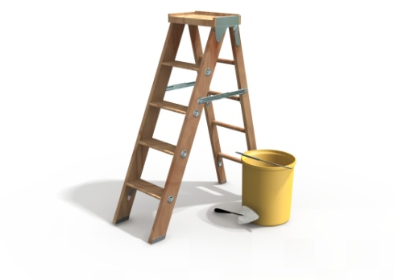
Types of equipment you may need include:
Ladders of different heights
- Never overstretch as you may fall
- Use a ladder that is the correct height for the task at hand and is stable when opened
- Never use a ladder where rungs are missing or where the ground is not flat
- Always open out the ladder to its full width
- Never stand on chairs or other furniture
- Never raise ladders by placing on bricks or similar - get a bigger ladder
- If the ladder is used in a busy area use correct signage to alert people of the potential hazard ahead.
Mobile scaffolding
- This may be used when changing ceiling lights in very high areas or painting ceilings for example
- You may be required to wear a safety harness attached to the side of the scaffolding in case you should slip. This will prevent you falling from a great height
- Never use this equipment alone and ensure the wheel brakes are locked before climbing on to it as it could roll
- Always wear a hard hat.
Cherry pickers
- These are similar to mobile scaffoldings in that they enable you to reach heights however you must be fully trained and accredited to use these
- Some are able to be driven from the platform but the platform must be lowered first to prevent toppling over
- When parked the stabilising arms must be locked out in full open position
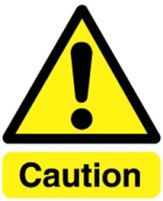
- You may be required to wear a safety harness attached to the cherry picker for your own safety
- Always wear a hard hat.
ALWAYS FOLLOW THESE SAFETY RULES.
Signage
When working overhead where there is a possibility that debris may fall, you have a huge responsibility to isolate the area below and place signage or barriers or both. This will prevent people from entering the area and may save a life should something heavy fall or is accidentally dropped.
Welding equipment
- When using welding equipment you will need to wear special leather gloves, a leather apron and a specially designed face mask to protect your eyes and body from sparks
- Welding should take place when there is nobody in the vicinity as it can be dangerous to others
- Correct fire fighting equipment should be readily available should there be a mishap
- Fire alarms may need to be turned off temporarily whilst welding is occurring
- In some countries a permit is needed to operate welding equipment.
Carpentry power tools
- There are many electrical power tools for use in carpentry and a knowledge of how each operates is vital before using them
- Never use tools you have not been trained to use
- Always wear goggles when using them and a face mask if they create a lot of wood dust
- Always clean up wood shavings after using them to minimise fire hazards
- Wear ear plugs to protect your hearing.
Paint sprayers
Paint spraying of furniture must be undertaken inside an airless booth. If not dust will be laid down with the paint and paint fumes will be transported via the air conditioning through the building. This smell can prove irritating to many people.
When paint spraying, always wear a protective suit and a respirator. Always use the correct cartridge in the respirator for the task at hand. This will need to be replaced every six to ten hours.

Maintaining work equipment
Some pieces of equipment in the workplace such as fridges, ovens, air conditioners or washing machines will each have their own instruction manual. These may help you in solving small problems before needing to call for professional outside specialist maintenance.

Protective equipment and clothing
Always ensure you wear the correct protective clothing for the task you are completing. In maintenance these include:
Types of protective clothing | When to wear it | Comments
Uniform | At all times | Your uniform has been designed for the job you have to perform  The uniform also represents the image of the company. Always wear it with pride and make sure it is clean and in good repair
Metal capped toe boots | When performing welding or heavy lifting | Protects the feet
Heavy duty gloves | Welding | For protection
Heavy duty apron | Welding | Protects normal clothing
Full face welder’s mask | Welding | Protects eyes and skin
Hard hats | When working in construction areas or performing high level work | Make sure it fits correctly and wear it properly not as a fashion item!
Ear plugs | When performing noisy work (drilling or sanding) | Protects hearing
Disposable paper suit | Paint spraying | Throw away after use
Respirator | Spray painting or using rust removers | Helps breathing. Make sure to change the cartridge after each use
High visibility vests | When working overhead or on roadways or in low visibility areas | Ensures you can be seen

4.3 Report problems and faults that require additional attention

Introduction
On occasions there may be pieces of work equipment that cannot be repaired or are repeatedly in a state of disrepair through constant use.
This may be because of age, spare parts no longer being available or through accidental or deliberate damage.

Reporting these faults
- When work equipment cannot be repaired it may be necessary to plan for replacement or upgrade of that item
- All work equipment would need to be replaced at some point
- Repeated continual repairs to one part of a machine and a cost analysis of those repairs will help to justify buying new equipment e.g. If a washing machine in the hotel laundry is 25 years old and is consistently breaking down, costing the company extra to send laundry out to an external laundry and for the machine repairs, then it could be reasoned that it would be more cost efficient to purchase and install a new machine
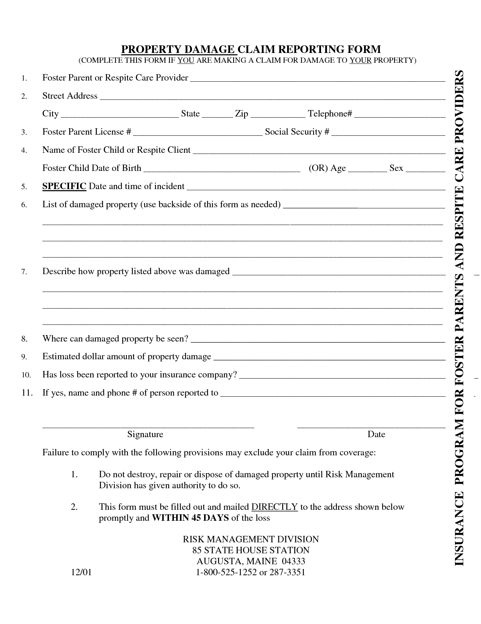
- Some faults may be a design issue e.g. if there are plate glass doors at the entrance to the restaurant and six people have walked into them, not having seen them , it may be argued that it is absolutely necessary to have sign writing on the glass or to improve lighting in the area in order to resolve the hazard
- Some upgrades to equipment may be necessary due to the rapid change in technology and requests from hotel guests e.g. Wi-Fi or iPod docking stations in guest rooms and public areas
- A written report to the Financial Controller and General Manager with costs incurred to date and quotes for replacement items should be given as and when required. It is important that they be made aware of these issues and allocate monies for these purchases when available
- Replacement items accidentally or deliberately damaged may be covered by insurance policies.

4.4 Store maintenance items and equipment

Introduction

In most properties there will be a separate workshop and storage areas for maintenance equipment. Depending on the size of the property there may be separate areas for each trade. A well organised and efficient maintenance department will always have enough spare parts and consumables to ensure a smooth operation. Whilst there will always be equipment breakdowns that are unavoidable, good purchasing procedures and stock control will minimise most problems.

What kind of items will need to be kept on hand?
These are many and varied. For example, a hotel or entertainment venue that has over 10,000 light fittings may have over 50 different types of light globes. In order to keep the venue illuminated, a stock of all the different types must be kept on hand.
A system of bin cards or a computer tracking system of stock should be used and knowledge of purchasing procedures and lead times is important.
Type of globe | Minimum stock level (Re-order level) | Used in | Current stock
25WBC | 60 | The Stuart Bar wall lights | 124
60WBC | 250 | All floor corridors on 36-50 | 80-purchase order pending
75WSBC | 120 | Used in chandeliers in Reception and Lobby | 150
100SES | 20 | In Café 94 ceiling lights | 42
100WBC yellow spotlights | 10 | Overhead planting on 5th floor | 15
100WES blue spotlights | 20 | Fountain | 21
With this example 60WBC globes should have already be ordered and blue spotlights will need to be ordered soon.
All items used by maintenance staff should be controlled in this way in larger venues.

Examples of other consumable items include but are not limited to:
- Nuts and bolts
- Nails and screws
- Curtain and blind fittings
- Hinges
- Locks and door furniture
- Air conditioning filters, fans and motors
- Glues
- Paints, varnishes and paint thinners. These should be stored separately to other consumables items due to their flammability
- Castors and wheels
- Electrical cabling
- Electrical plugs, sockets and wall switches
- Light switches, light fittings and covers
- Thermostats
- Tiles and grouting
- Spare carpet for each area
- Plumbing fixtures, tap washers, toilet seat, toilet pans, wash basins
- All these items will need to be stored in a methodical way for easy access when needed.
Tools
Tools are not consumables and, due to the high cost of these items, should be secured at all times. Tools include all hand and electrical items.
Each trade will usually have their own toolboxes which should be kept locked when not in use. The toolboxes should be stocked with enough equipment for staff to do their jobs efficiently and checked at the end of each day. Consumable items should be replaced and any missing tools should be reported. Usually in a hotel, tools may be overlooked when cleaning up after a task so it is important to retrace the completed tasks to search for tools. Failure to care and control these items will result in additional unnecessary expense for the hotel.
Stock takes
In most venues, a monthly stock take of all consumables is undertaken for cost control and purchasing procedures. Stock taking may highlight any unusual usage of items or possible theft. Obsolete stock may also be identified.

4.5 Perform required administrative tasks

Introduction
Most administrative tasks in the maintenance department relate to stock control, managing costs and contracts and reporting back.
Controlling equipment
At times some operational items may have to be removed off-site for repairs. If there is no on-site upholsterer for example, then chairs may have to go off-site to be recovered. The maintenance manager must ensure that the quantity of chairs that go off-site are all returned. This is done by using an ‘outgoing record form’. A copy is given to the contractor and a copy retained in maintenance.
If fabric is supplied by the hotel then that also needs to be controlled. If there are ten chairs to be recovered and each chair needs three metres of fabric, then 30 metres of fabric should be given to the upholsterer.
All reserve carpets and fabrics must be accounted for on stock sheets as and when used.
Reporting
Maintenance works in conjunction with all departments. They must co-operate and communicate with most departments on a daily basis. Once maintenance requests are completed, it must be reported back to the department so that they know that the room or equipment can be used again. Housekeeping or Kitchen staff may need to make a final clean of an area or a piece of equipment before using.
Other records kept by maintenance
Instruction or operational manuals for each piece of work equipment that requires servicing or maintenance.
This is an instructional manual that will advise how equipment works. It may help to solve small problems.
Maintenance manuals
This is a very important document and should be readily available. The information it contains will tell you
- Which parts of the equipment to clean daily/weekly/monthly
- The frequency of inspections and which parts of the machine to inspect
- What to look for in these inspections
- What type of lubricants to use, where and with what frequency
- Spare part numbers (this will help when re-ordering)
- Recommended spare parts that should be kept on-site
- Recommendations on how often certain pieces may need to be replaced (motors, valves, switches, thermostats).

Maintenance schedules
This is a plan of all known regular preventative and planned maintenance. It is usually in the form of a 12 month planner which is posted on the wall for easy visibility.
Machine record cards
There should be a record machine for each large piece of equipment (commercial fridges, ovens, grills, laundry equipment, dishwashing machines, and large cleaning equipment). This card should record:
- The model number of the machine
- The serial number of the machine
- The date of purchase and warranty details
- Manufacturer's name and contact details (who to call in case of problems or service needed)
- Spare parts held on site and spare part numbers
- All completed maintenance including inspections and lubrication including when the maintenance was done and by whom. This will assist contractors should you need to call for professional maintenance.
Other records to be kept
- Staff rosters including sick days, holidays with all relevant paperwork
- Payroll costs
- Purchase orders for all goods
- Monthly stock take figures of all consumables with cost analysis
- Number of work requests per trade per month
- Any major unplanned projects and costs
- Cost of unexpected repairs
- List of all contractors with all telephone numbers
- Emergency (after hours contacts)
- Water treatment records
- Machinery repairs
- Sewage, water and power costs
- Boiler service records
- Reports from outside government bodies for compliance (fire department, health authorities).

4.6 Assist in special projects, where required

Introduction
Periodically there may be planned maintenance or refurbishments projects that will need detailed planning and organisation.

Upgrades to guest rooms
In any hotel changes to guest rooms must be planned in detail to maximise revenue. In many cases changes can be made without any loss of revenue.
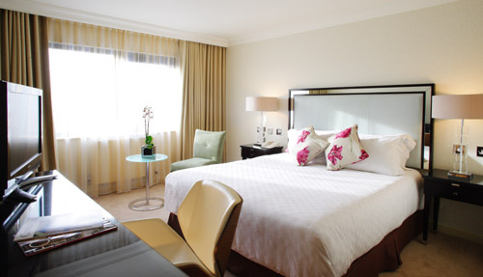
- Rooms can be sold overnight
- The guest checks out
- Housekeeping staff strip the room
- The item is changed over (beds or carpets)
- The room is cleaned and released back for sale.
Where extensive refurbishment takes place and construction work is undertaken such as bathrooms replaced or walls knocked down, then rooms may be out of service for longer periods. This must be planned well ahead so that rooms will not be sold in advance.

Upgrades to public areas
Planned upgrades to public areas must also be planned in line with occupancy levels and business needs.
Replacing carpet in a function room will not be as difficult as in the main lobby and reception area which is open 24 hours a day. Function rooms can be closed for a day or more whilst carpet is laid but in Reception, carpet may have to be replaced in sections overnight when there is less traffic.
If a task will be noisy, consideration should be given to relocating guests from rooms adjacent or above these areas. Carpet laying for example generates quite a bit of noise.
Similar consideration should be given to other tasks where noise is inevitable such as drilling or hammering.

Replacing major equipment
When large pieces of work equipment need to be replaced such as an oven in the kitchen or a washing machine in the laundry, this must be planned very carefully. Usually this type of work will be done by specialised outside contractors who will provide the labour.
The obsolete piece of equipment must be disconnected from all utilities (gas, electricity or steam) and isolated and this is where onsite maintenance staff can assist. They will guide the contractor by advising the location of power supplies and isolating valves.
The obsolete machinery is then removed from site by special lifting equipment. This may need to be hired if not supplied by the installation company. This work should be done after hours when the least disruption will occur.
The area where the item has been removed should be cleaned and all utilities checked. It may be necessary to modify existing pipe work or drains to accommodate the new piece of equipment and this should be done before installation of the new item.
Once the new item is installed its operation should be fully checked before use.
All staff including maintenance staff will need to be trained in the correct use of the new equipment.

Assisting with other projects
Whilst every property is different, other special projects not already mentioned may include:
- Swimming pool and spa maintenance (painting or re-tiling)
- Exterior building cleaning including cleaning of signage
- Relaying of paving on pathways
- Renewal of tennis court surfaces
- Antique restoration.

4.7 Liaise with external contractors

Introduction
There will always be a need to use external contractors in the maintenance of all buildings. Sometimes the need will be urgent but mostly the work will be planned maintenance on a regular schedule.

When to use contractors
Contractors will usually be more expensive than using in-house staff but their specialised knowledge is vital in providing support and service for specific equipment. If there is a written contract between the property and the contractor, then this will stipulate all conditions, charges and the parameters of the contract.
If contractors are used on a casual basis then they will usually charge per hour and for all spare parts they use.

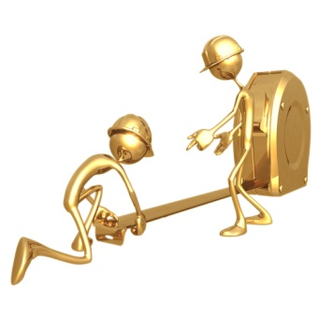
There are advantages and disadvantages in using contractors.
Advantages | Disadvantages
The hotel does not have to employ certain trade personnel in order to perform short term work  The contractor will provide specially trained personnel  The use of contracted staff will allow permanent staff to carry out their normal duties  The cost of contractors can be more readily budgeted for  Short-term contractors can be used if in- house staff are on holidays or absent. | The contracted personnel may be unfamiliar with the property and may need somebody to assist them to locate power sources and isolation valves  The contractor may not work as part of the team and may have divided loyalties  Contractors may not arrive on time for a scheduled appointment and this may impact on service needs when there is only limited time to perform this function  The contractor may provide different staff each time who will be unfamiliar with the property
It is important to co-operate with all contractors so that the scheduled work is carried out with minimum disruption to the normal daily operation.
If contractors are performing normal planned maintenance, then this should be straightforward.
If contractors are called in for emergency situations for issues that are unable to be fixed, it is vital that as much information as possible be given to them in order for them to understand the problem and seek a possible solution.

Managing contracts
The Maintenance manager may be responsible for managing both casual (as required) and contracted companies.
Examples of managed contracts include:
Utility suppliers - Cost of electricity, gas, water
In small motels there may only be one meter for each utility but in very large entertainment venues, there will be several. In this way, costs incurred in each area may be monitored and, if excessive, a review of usage may be done and recommendations made for cost saving measures (e.g. placing lighting on timers or turning off air conditioners overnight).
Water treatment/ Boiler inspections
Water treatment specialists and boiler inspectors will have planned service calls and inspections. They will submit a written report with observations and recommendations which should be acted upon as needed.

Lift and escalator maintenance
Lift and escalator maintenance must be done by qualified technicians on a very regular basis. In large entertainment venues where there are many lifts, there may be a permanent lift technician on site.
In high rise buildings, lifts should be checked weekly. If a lift needs urgent repair it must be taken out of service immediately for safety's sake. This must be communicated to all parties so that other arrangements can be made.
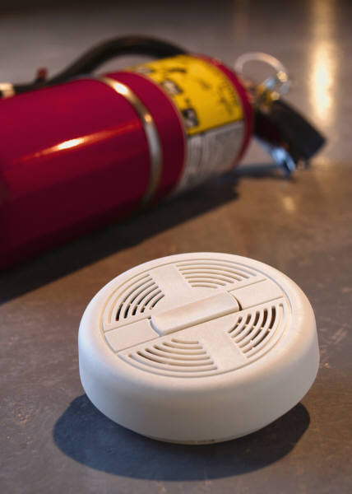
Fire fighting equipment
This is usually checked by a specialised fire fighting equipment company in conjunction with the local fire brigade. The contractors will inspect all fire fighting equipment including alarms, smoke detectors, sprinklers, fire extinguishers, hoses, automatic fire doors and fire exits. Written reports of any shortcomings or recommendations must be actioned.
General Equipment contractors
These include external companies such as cleaning equipment servicemen e.g. If the hotel has 80 vacuum cleaners, there will usually be in place a service contract for regular servicing of all machines (every three months). The technicians will come in over a period of days and check and service all vacuum cleaners. They will change filters, and repair motors and make general recommendations if they are aware of any operational issues. It is incumbent on the maintenance manager to ensure all contractors perform the required tasks on a timely basis.

Other contractors may include:
- Supply and upkeep of plants
- Pest control
- Washroom Hygiene (supply of sanitary units and urinal sanitising units)
- Refrigeration maintenance
- Laundry equipment maintenance
- Waste contractors
- Window cleaners.

Work Projects
It is a requirement of this Unit that you complete Work Projects as advised by your Trainer. You must submit documentation, suitable evidence or other relevant proof of completion of the project to your Trainer by the agreed date.
1. Choose an area of your workplace and identify all maintenance tasks that would have to be carried out periodically.
2. Demonstrate the changing of a light globe which is higher than three meters.
3. Prepare a short report with costing for your Manager on the necessity to replace the hot water extraction unit.
4. Prepare a list of all carpentry consumables in your workplace.

Summary

Maintain industrial work areas and equipment
Identify tasks to be undertaken:
Identify the different classifications of maintenance
Report maintenance issues
Identify the different trades
Perform maintenance tasks:
Perform daily tasks
Respond promptly to requests
Use correct equipment
Understand safety restrictions
Maintain work equipment
Select appropriate protective clothing
Report faults that require additional attention
Store maintenance equipment
Understand requisitioning and stock control procedures
Identify spare parts
Perform administrative tasks:
Control equipment
Keep records
Read maintenance manuals
Assist in special projects
Replace major equipment
Remove old equipment
Liaise with external contractors:
Know when to use contractors
Manage contracts

Presentation of written work

1. Introduction
It is important for students to present carefully prepared written work. Written presentation in industry must be professional in appearance and accurate in content. If students develop good writing skills whilst studying, they are able to easily transfer those skills to the workplace.

2. Style

Students should write in a style that is simple and concise. Short sentences and paragraphs are easier to read and understand. It helps to write a plan and at least one draft of the written work so that the final product will be well organised. The points presented will then follow a logical sequence and be relevant. Students should frequently refer to the question asked, to keep ‘on track’. Teachers recognise and are critical of work that does not answer the question, or is ‘padded’ with irrelevant material. In summary, remember to:
- Plan ahead
- Be clear and concise
- Answer the question
- Proofread the final draft.

3. Presenting Written Work
Types of written work
Students may be asked to write:
- Short and long reports
- Essays
- Records of interviews
- Questionnaires
- Business letters
- Resumes.
Format
All written work should be presented on A4 paper, single-sided with a left-hand margin. If work is word-processed, one-and-a-half or double spacing should be used. Handwritten work must be legible and should also be well spaced to allow for ease of reading. New paragraphs should not be indented but should be separated by a space. Pages must be numbered. If headings are also to be numbered, students should use a logical and sequential system of numbering.
Cover Sheet
All written work should be submitted with a cover sheet stapled to the front that contains:
- The student’s name and student number
- The name of the class/unit
- The due date of the work
- The title of the work
- The teacher’s name
- A signed declaration that the work does not involve plagiarism.
Keeping a Copy
Students must keep a copy of the written work in case it is lost. This rarely happens but it can be disastrous if a copy has not been kept.
Inclusive language
This means language that includes every section of the population. For instance, if a student were to write ‘A nurse is responsible for the patients in her care at all times’ it would be implying that all nurses are female and would be excluding male nurses.
Examples of appropriate language are shown on the right:
Mankind | Humankind
Barman/maid | Bar attendant
Host/hostess | Host
Waiter/waitress | Waiter or waiting staff

Recommended reading
Robert J. Martin & Thomas Jones, Professional Management of Housekeeping Operations, Wiley
Tucker & Schneider, The Professional Housekeeper, Cahners (USA)
Iris Jones & Cynthia Phillips, Commercial Housekeeping and Maintenance, Stanley Thornes (UK)
Doris Hatfield & Christine Winter, Professional Housekeeping, Hutchinson (UK)
David M Allen, Accommodation & Cleaning Services/Operations, Hutchinson (UK)
JKP Edwards, Floors and their maintenance, Cresta (UK)
Lia Low, Keep it Clean, The Bodley Head (UK)
Branson & Lennox, Hotel Housekeeping, Edward Arnold (UK)

Trainee evaluation sheet

Clean and maintain industrial work area and equipment
The following statements are about the competency you have just completed.
Please tick the appropriate box | Agree | Don’t Know | Do Not Agree | Does Not Apply
There was too much in this competency to cover without rushing.
Most of the competency seemed relevant to me.
The competency was at the right level for me.
I got enough help from my trainer.
The amount of activities was sufficient.
The competency allowed me to use my own initiative.
My training was well-organised.
My trainer had time to answer my questions.
I understood how I was going to be assessed.
I was given enough time to practice.
My trainer feedback was useful.
Enough equipment was available and it worked well.
The activities were too hard for me.

The best things about this unit were:

The worst things about this unit were:

The things you should change in this unit are:

Trainee self-assessment checklist
As an indicator to your Trainer/Assessor of your readiness for assessment in this unit please complete the following and hand to your Trainer/Assessor.

Clean and maintain industrial work area and equipment
 |  | Yes | No*
Element 1: Identify cleaning and maintenance requirements
1.1 | Identify work areas to be cleaned and maintained
1.2 | Identify work equipment to be cleaned and maintained
1.3 | Identify and locate instructions in relation to cleaning and maintenance
Element 2: Clean industrial work areas
2.1 | Assess area to be cleaned
2.2 | Select appropriate cleaning equipment and chemicals
2.3 | Select the protective clothing and equipment to be used
2.4 | Prepare the area
2.5 | Undertake the selected cleaning process
2.6 | Dispose of waste
2.7 | Return area to operational condition
2.8 | Clean, check and store cleaning equipment and chemicals
Element 3: Clean industrial work equipment
3.1 | Assess suitability of equipment for cleaning
3.2 | Select appropriate cleaning equipment and chemicals
3.3 | Select the protective clothing and equipment to be used
3.4 | Prepare equipment for cleaning
3.5 | Clean equipment as identified
3.6 | Tidy work site
3.7 | Dispose of waste
3.8 | Clean, check and store cleaning equipment and chemicals
Element 4: Maintain industrial work areas and equipment
4.1 | Identify maintenance tasks to be undertaken
4.2 | Perform maintenance tasks, as required
4.3 | Report problems and faults that require additional attention
4.4 | Store maintenance items and equipment
4.5 | Perform required administrative tasks
4.6 | Assist in special projects, where required
4.7 | Liaise with external contractors

Statement by Trainee:
I believe I am ready to be assessed on the following as indicated above:
Signed: _____________________________ | Date: ____________

Note:
For all boxes where a No* is ticked, please provide details of the extra steps or work you need to do to become ready for assessment.





